CSS— (CASCADING STYLE SHEET)

Comment in CSS-- > /* description */

Syntax🡪

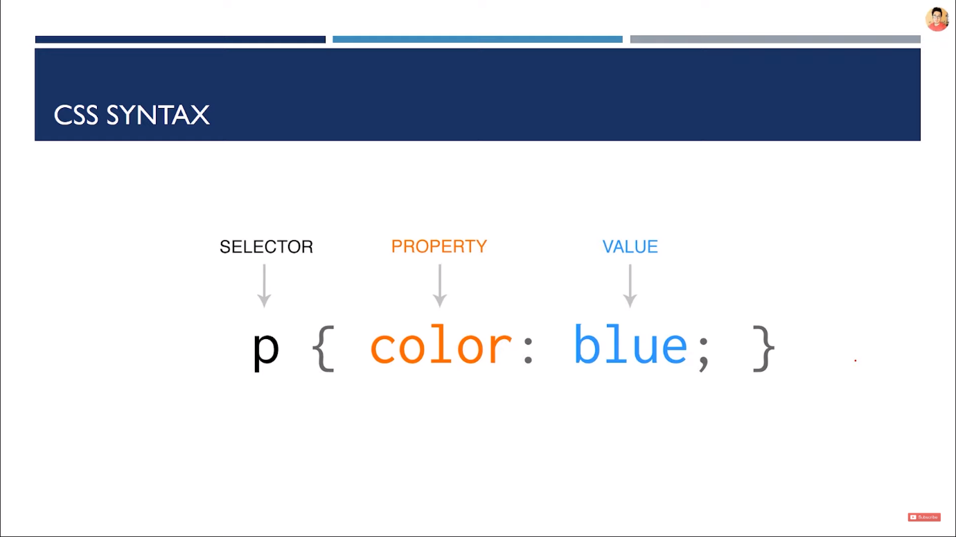

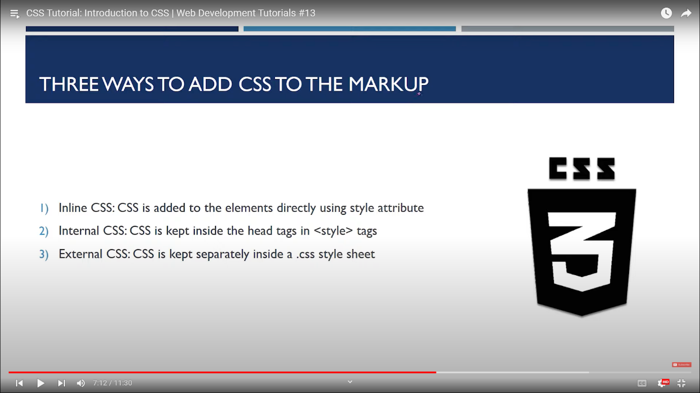

1. Inline CSS 🡪
2. <body>
3. <header>
4. <h3 style="color: brown;">This is CSS tutorial</h3>
5. <p style="color: yellowgreen;">Lorem ipsum dolor sit amet consectetur, adipisicing elit. Aliquam, qui.</p>
6. </header>
7. </body>

2) internal CSS🡪

<!DOCTYPE html>

<html lang="en">

<head>

    <meta charset="UTF-8">

    <meta http-equiv="X-UA-Compatible" content="IE=edge">

    <meta name="viewport" content="width=device-width, initial-scale=1.0">

    <title>Document</title>

    <style>

        h3{

*color*: aqua;

        }

        p{

*color*: brown;

        }

    </style>

</head>

<body>

    <header>

        <h3 >This is CSS tutorial</h3>

        <p>Lorem ipsum dolor sit amet consectetur, adipisicing elit. Aliquam, qui.</p>

    </header>

</body>

</html>

3) external css🡪

<!DOCTYPE html>

<html lang="en">

<head>

    <meta charset="UTF-8">

    <meta http-equiv="X-UA-Compatible" content="IE=edge">

    <meta name="viewport" content="width=device-width, initial-scale=1.0">

    <title>Document</title>

    <link rel="stylesheet" href="pr.css">

</head>

<body>

    <header>

        <h3 >This is CSS tutorial</h3>

        <p>Lorem ipsum dolor sit amet consectetur, adipisicing elit. Aliquam, qui.</p>

    </header>

</body>

</html>

CSS program for external CSS 🡪

h3{

*color*: aqua;

*text-align*: center;

*background-color*: burlywood;

}

p{

*color*: yellow;

*font-size*: large;

*text-align*: left;

}

CSS precedence 🡪

Use of important 🡪 as (! important)

<style>

        p{

*color*: blue;

*background-color*: aqua !important;

        }

    </style>

Selector->

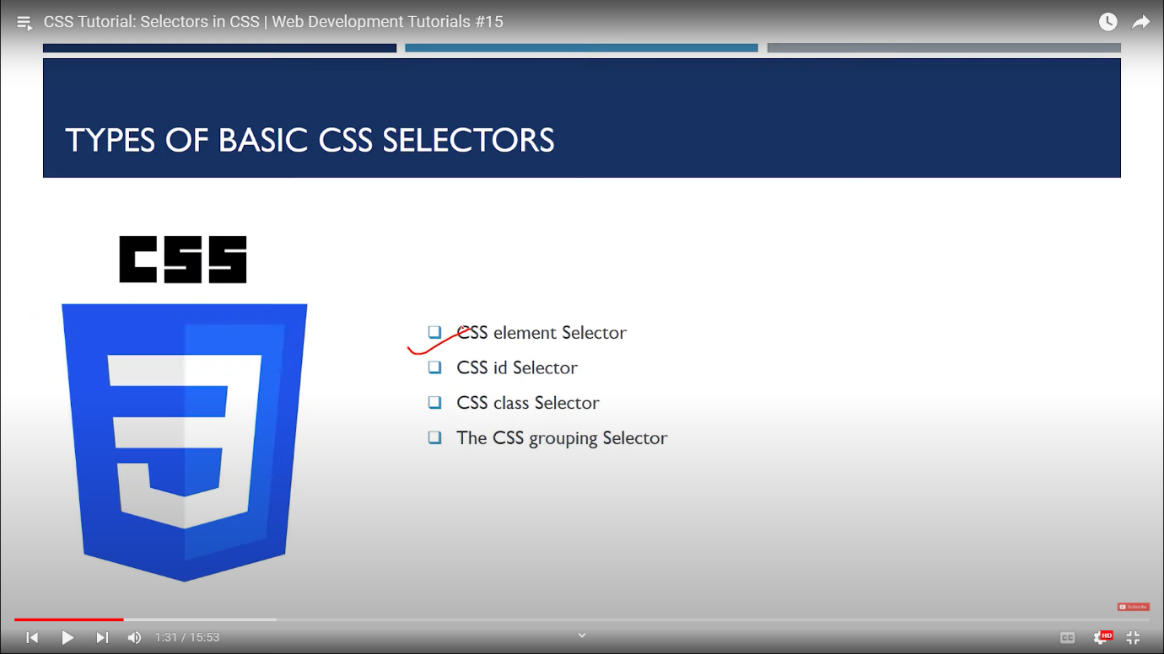

1. CSS element selector 🡪
2. <style>
3. h1{
4. color: coral;
5. text-align: center;
6. }
7. p{
8. color: crimson;
9. background-color: aquamarine !;
10. }
11. </style>
12. </head>
13. <body>
14. <header>
15. <h1>About CSS</h1>
16. <p>Lorem ipsum dolor sit amet consectetur adipisicing elit. Eaque blanditiis aliquid sint beatae nam dolores?</p>
17. <p>Lorem ipsum dolor sit amet consectetur adipisicing elit. Eaque blanditiis aliquid sint beatae nam dolores?</p>
18. <p>Lorem ipsum dolor sit amet consectetur adipisicing elit. Eaque blanditiis aliquid sint beatae nam dolores?</p>
19. <p>Lorem ipsum dolor sit amet consectetur adipisicing elit. Eaque blanditiis aliquid sint beatae nam dolores?</p>
20. </header>
21. </body>

* 2 ) **Class Selector**
* <style>
* .redElement{
* Color: red;
* }
* .bgBlue{
* Background-color: blue;
* }
* </style>

<h3>CSS Selectors</h3>

             <p id="firstPara">This is a simple paragraph to demonstrate css selectors</p>

             <p id="secondPara" class="redElement bgBlue">This is a another simple paragraph to demonstrate css selectors</p>

<div>

       <p>This is yet another simple paragraph inside div to demonstrate css selectors</p>

</div>

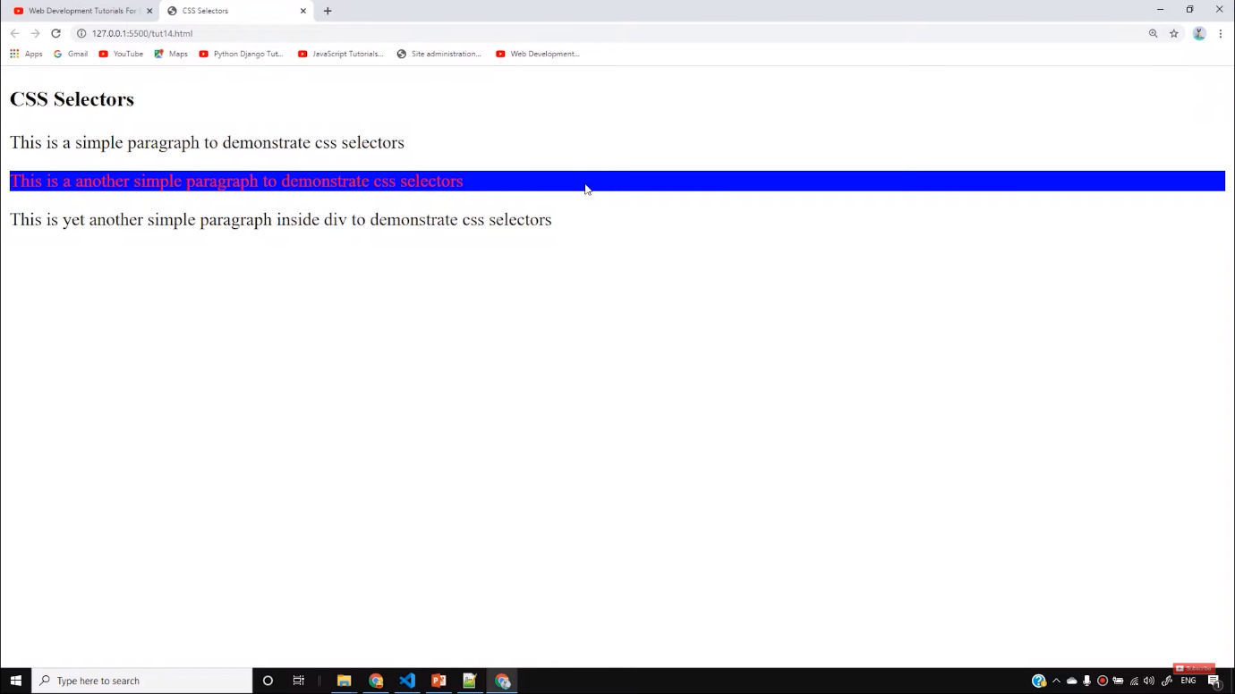

* **ID Selector**
* <style>
* #firstPara{
* color: green;
* }
* </style>

<body>

    <h3>CSS Selectors</h3>

    <p id="firstPara">This is a simple paragraph to demonstrate css selectors</p>

    <p>This is a another simple paragraph to demonstrate css selectors</p>

    <div>

        <p>This is yet another simple paragraph inside div to demonstrate css selectors</p>

    </div>

</body>

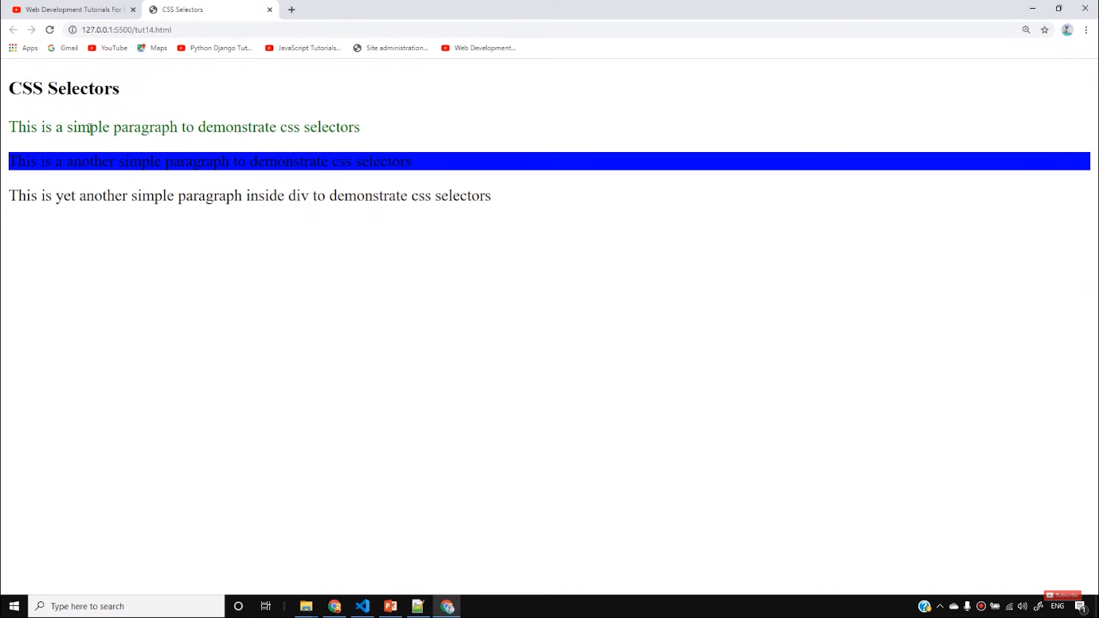

* **Grouping Selector**
* <style>
* footer, span{
* Background-color: pink;
* }
* </style>

<body>

    <h3>CSS Selectors</h3>

    <p>This is a simple paragraph to demonstrate css selectors</p>

    <p>This is a another simple paragraph to demonstrate css selectors</p>

    <div>

        <p>This is yet another simple paragraph inside div to demonstrate css selectors</p>

        <span>this is span</span>

    </div>

    <footer>This is footer</footer>

</body>

UNVIRSAL SLECTOR :

*{

*box-sizing*: border-box;

*margin*: 0;

*padding*: 0;

}

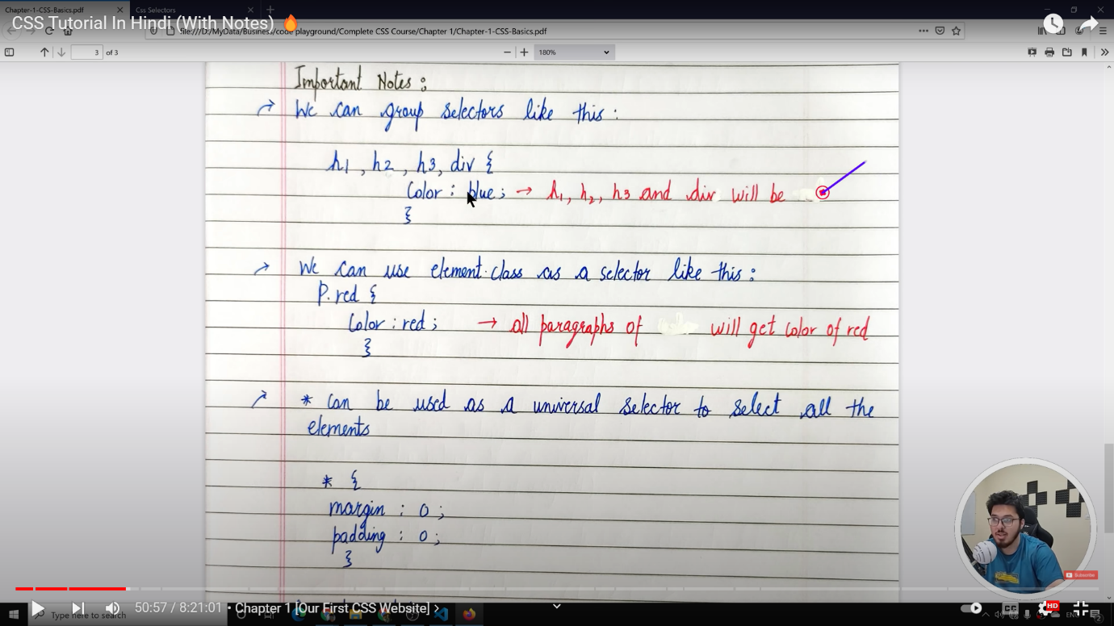

Whole code 🡪

<!DOCTYPE html>

<html lang="en">

<head>

    <meta charset="UTF-8">

    <meta name="viewport" content="width=device-width, initial-scale=1.0">

    <meta http-equiv="X-UA-Compatible" content="ie=edge">

    <title>CSS Selectors</title>

    <style>

        /* Element selector */

        p{

            border: 2px solid red;

        }

        /* Id selector */

        #firstPara{

            color: green;

        }

        /* Class selector */

        .bgBlue{

            color: yellow;

            background-color: blue;

        }

        /* Grouping selector */

        footer, span{

            background-color: pink;

        }

    </style>

</head>

<body>

    <h3>CSS Selectors</h3>

    <p id="firstPara">This is a simple paragraph to demonstrate css selectors</p>

    <p id="secondPara" class="redElement bgBlue">This is a another simple paragraph to demonstrate css selectors</p>

    <div>

        <p>This is yet another simple paragraph inside div to demonstrate css selectors</p>

        <span>this is span</span>

    </div>

    <footer>This is footer</footer>

</body>

</html>

When to use id and when to use class 🡪

Id – when I have to perform any operation in particular element then I can prefer using id .

Class – when I have to apply a particular CSS operation on large no of element then I can prefer using class.

***🡪

Using Chrome Developer Tools

CSS font 🡪

<https://www.w3schools.com/cssref/pr_font_font.asp>

font-shortened : font: *font-style* *font-variant* *font-weight* *font-size/line-height font-family*|caption|icon|menu|message-box|small-caption|status-bar|initial|inherit;

<button onclick="myFunction()">Try it</button>

<!DOCTYPE html>

<html lang="en">

<head>

    <meta charset="UTF-8">

    <meta name="viewport" content="width=device-width, initial-scale=1.0">

    <meta http-equiv="X-UA-Compatible" content="ie=edge">

    <title>CSS Fonts</title>

    <link href="https://fonts.googleapis.com/css?family=Ubuntu&display=swap" rel="stylesheet">

    <style>

        p{

*font-family*:'Ubuntu', 'Franklin Gothic Medium', 'Arial Narrow', Arial, sans-serif;

*font-size*: 33px; /* 1/96th of an inch */

*line-height*: 1.3em;

        }

        span{

*font-weight*: bold;

*font-style*: italic;

        }

    </style>

</head>

<body>

    <h4>CSS Fonts</h4>

    <p>Lets play with <span>fonts</span>. It is very exciting</p>

</body>

</html>

CSS COLOR 🡪

Generally, we have 3 type of colour

i)- colour by name

ii)- colour by rbg(12,54,78)

iii) – hexacolor (#rf67yt)

relation between rbg and hex –

rf=12(r) , 67=54(b) , yt =78 (g)

v) rgba(12,54,78,0.7)

vi) hsla (9,100%,64% ,0.7)

iv) **hsl(9, 100%, 64%) 99**

<!DOCTYPE html>

<html lang="en">

<head>

    <meta charset="UTF-8">

    <meta name="viewport" content="width=device-width, initial-scale=1.0">

    <meta http-equiv="X-UA-Compatible" content="ie=edge">

    <title>Colors in CSS</title>

    <style>

        #firstPara{

*color*:blueviolet; /* Color by name */

        }

        #secondPara{

*color*: rgb(223, 130, 54); /* Color by rgb value */

        }

        #thirdPara{

*color*: white;

*background-color*: #ff4532; /* Color by hex value */

        }

    </style>

</head>

<body>

    <h2>This is my first box</h2>

    <p id="firstPara">This is a paragraph from first box</p>

    <h2>This is my first box</h2>

    <p id="secondPara">This is a paragraph from second box</p>

    <h2>This is my first box</h2>

    <p id="thirdPara">This is a paragraph from third box</p>

</body>

</html>

Rgb 🡪

Hxa 🡪

<https://www.w3schools.com/css/css_colors_hex.asp>

HSL 🡪

<https://www.w3schools.com/css/css_colors_hsl.asp>

width, height, border and background 🡪

<body>

    <h3>This is heading</h3>

    <p id="firstPara">This is a paragraph</p>

    <h3>This is second heading</h3>

    <p id="secondPara">This is my second paragraph</p>

    <h3>This is third heading</h3>

    <p id="thirdPara">This is my third paragraph</p>

</body>

#firstPara{

    background-color: red;

    height: 100px;

    width:455px;

    border: 4px solid green;

    /* border-width: 4px;

    border-color: green;

    border-style: solid;  */

    border-radius: 11px;

}

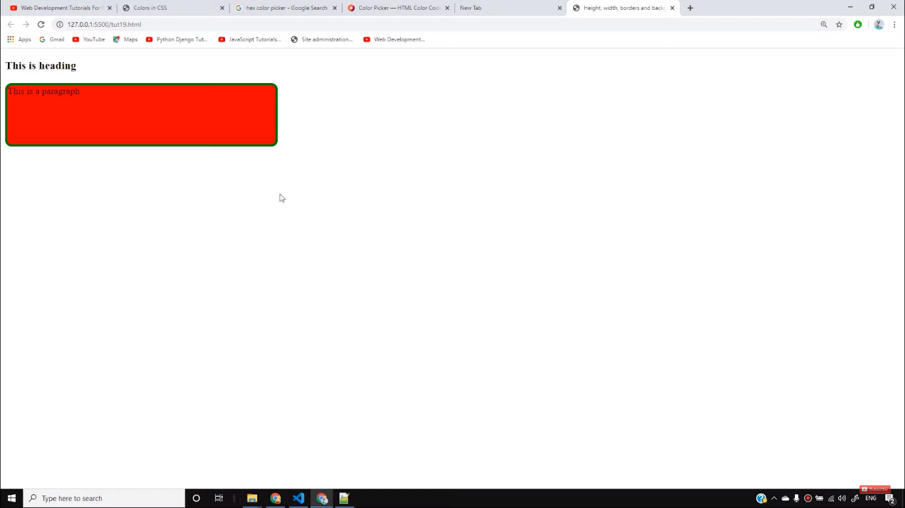

#secondPara{

        background-color: rgb(58, 243, 98);

        height: 100px;

        width:455px;

        border-top: 2px solid rgb(231, 22, 231);

        border-right: 2px solid rgb(18, 10, 133);

        border-bottom: 2px solid rgba(9, 144, 27, 0.774);

        border-left: 2px solid rgb(156, 42, 13);

        border-top-left-radius: 4px;

        border-top-right-radius: 14px;

        border-bottom-left-radius: 8px;

        border-bottom-right-radius: 24px;

    }

Background-size : 100% 100% /* image ko stretch kar ke laga dega

body{

    background : url("Madhubala1957.png") no-repeat fixed;

    background-size: 100% 100%;

}

Background-size :cover ; /* it will automatically resize our background with bluring or photo fatana .

Note – by using cover kuch na kuch image ka part katega so be carefull while using it

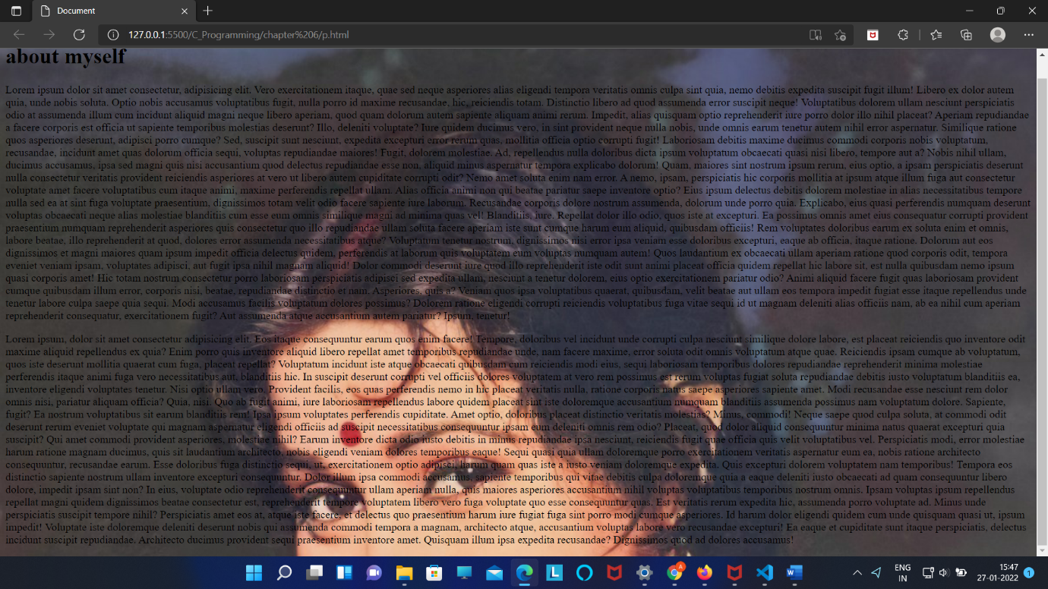

Background-size :contain /* ye image ka hundered ka hu bahu laga dega par sarabackground cover nahi bhi hosakta hai

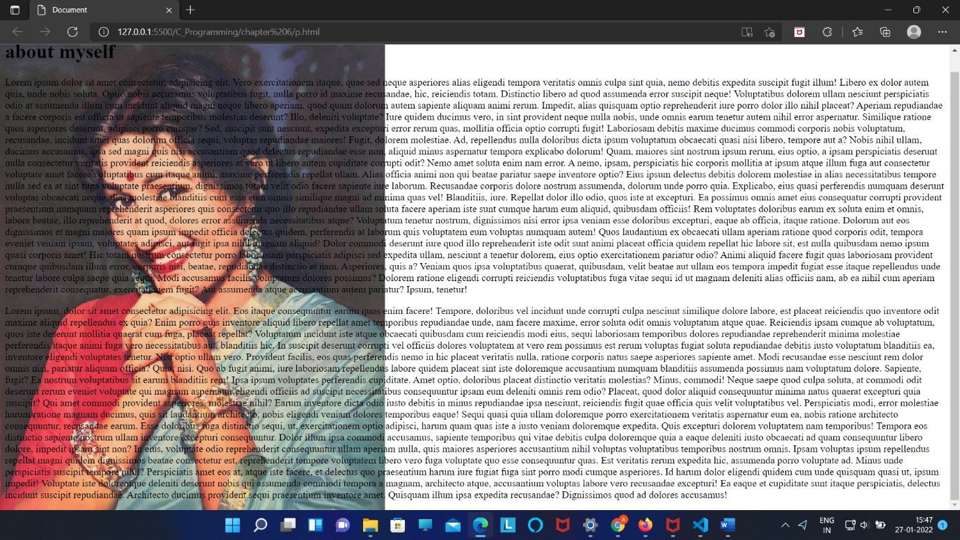

Background size property :

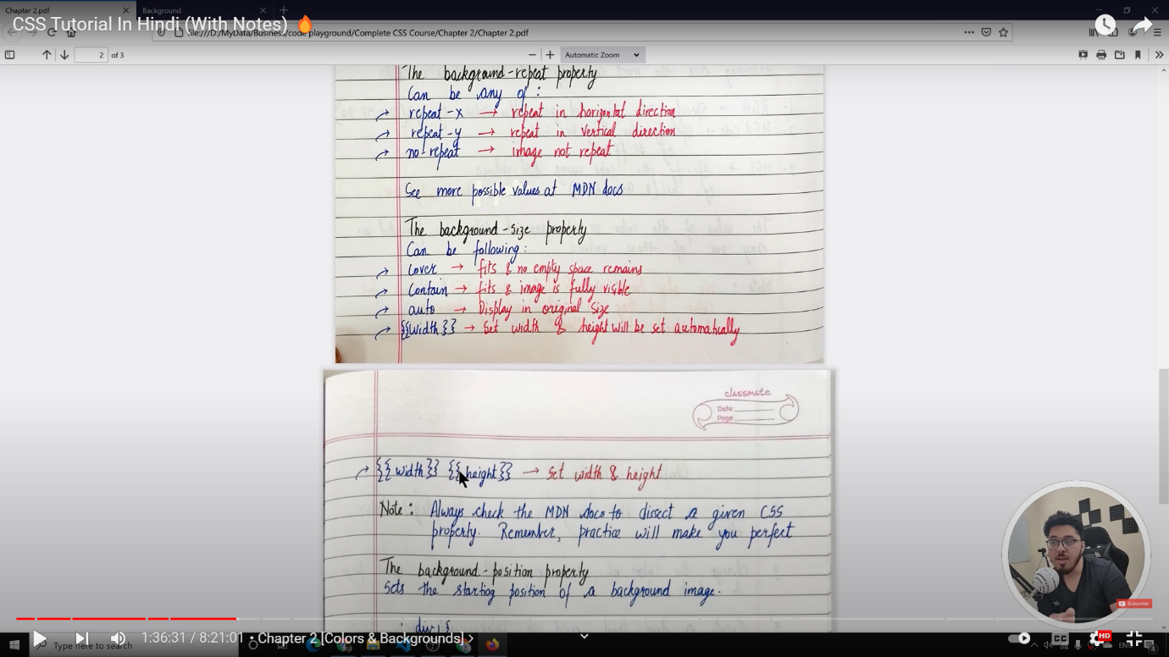

Using multiple image in same background :

body{

    background-image: url('Hema_malini_bhungama1.jpg') , url('Madhubala1957.png');

    background-repeat: no-repeat no-repeat;

    background-size: contain ,contain;

    background-position: left top ,right bottom;

}

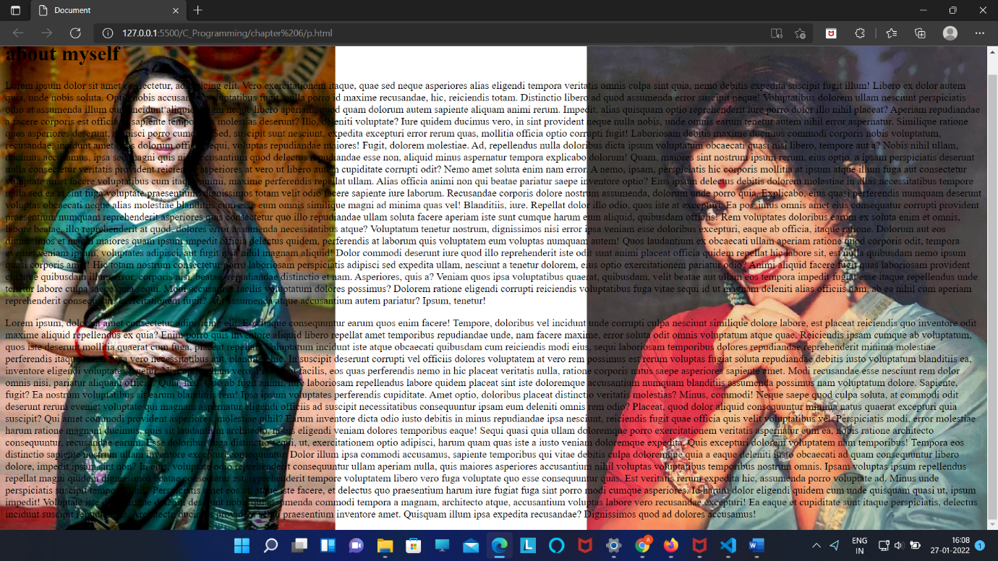

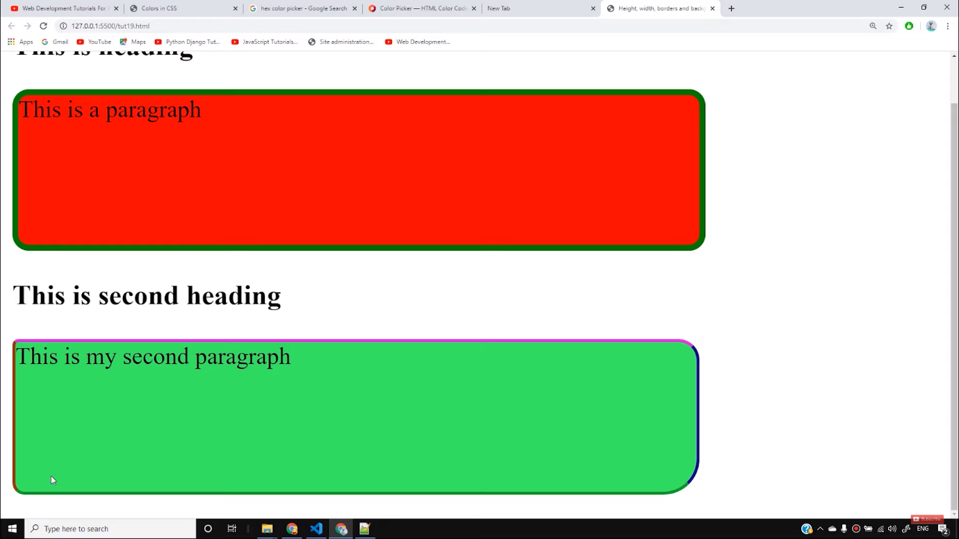

 #thirdPara{

        height: 500px;

        width:455px;

        background-image: url('https://codewithharry.com/static/common/img/photo.png');

        border: 2px solid red;

        background-repeat: no-repeat; /* repeat-x and repeat-y will make it repeat on x and y axis */

        /* background-position: 192px 34px; */

        background-position: center center;

        /* background-position: bottom right; */

        /* background-position: top center; */

      }

Border ->

Way of giving each (top ,right, bottom, left) different property

Border-style : solid dashed doted none ;

Way to give top-bottom and right-left same border property

Border -style: solid dashed :

Width- height :

| **Box Size** | **Calculation** |
| --- | --- |
| Total Width | width + padding-left + padding-right + border-left + border-right + margin-left + margin-right |
| Total Height | height + padding-top + padding-bottom + border-top + border-bottom + margin-top + margin-bottom |

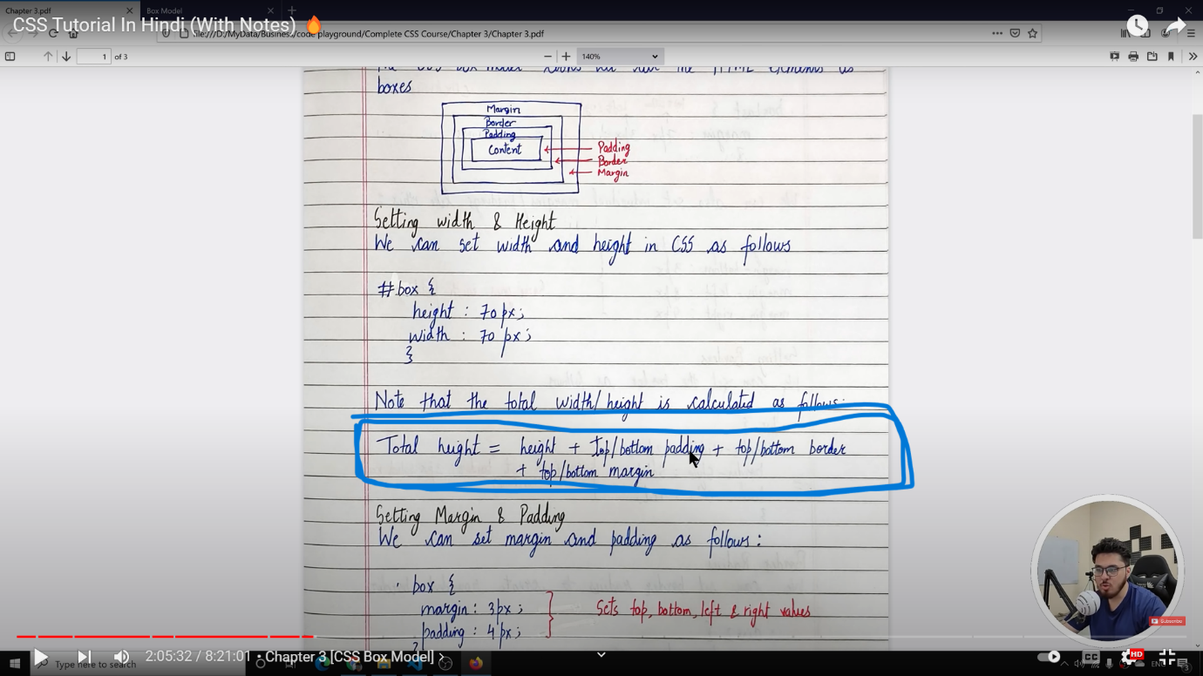

BOX-SIZING :

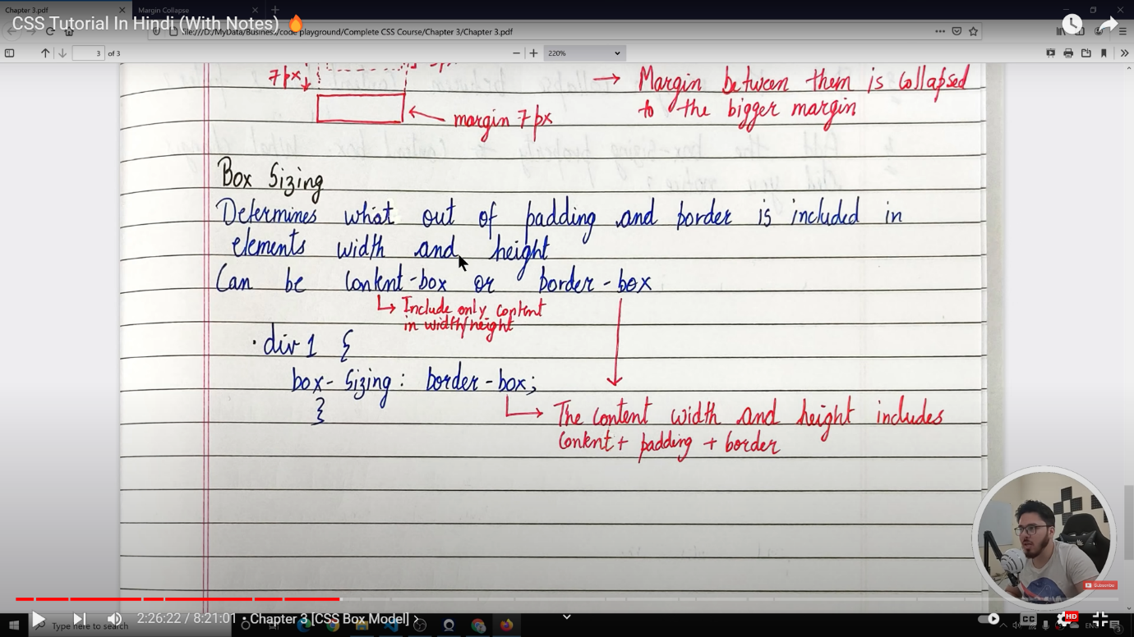

Box model 🡪

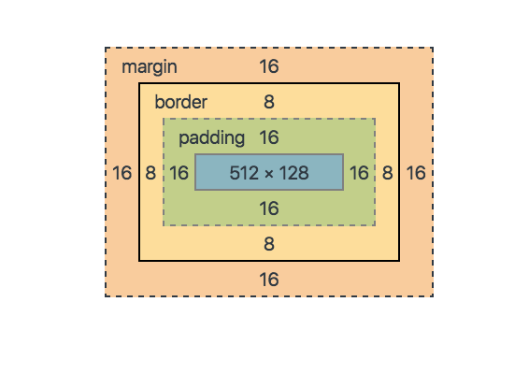

1. Padding / margin : 10 px; means padding / margin in all top(10px) right(10px) bottom(10px) left(10px)
2. For padding and margin in x – axis and y-axis

Padding / margin : 10px 34px;

Where 10px - (top-bottom(y-axis) )

34px – righ-left(x-axis) padding / margin

Important attributes –

Box-sizing :border-box ; (stop of increasing of margin or border or paddling

<!DOCTYPE html>

<html lang="en">

<head>

    <meta charset="UTF-8">

    <meta name="viewport" content="width=device-width, initial-scale=1.0">

    <meta http-equiv="X-UA-Compatible" content="ie=edge">

    <title>Box Model</title>

    <style>

        * {

*box-sizing*: border-box;

*margin*: 0;

*padding*: 0;

        }

        body{

*background-color*: #e6cbf8;

        }

        .container{

*background-color*: rgb(231, 230, 241);

*border*: 3px solid rgb(64, 6, 119);

            /* We can set margin/padding for  top, bottom, left and right like this */

            /* padding-top: 79px;

            padding-bottom: 79px;

            padding-left: 34px;

            padding-right: 79px;*/

            /* margin-top: 3px;

            margin-bottom: 5px;

            margin-left: 34px;

            margin-right:5px ; */

            /* margin = top right bottom left;  */

            /* padding = top right bottom left;  */

            /* padding: 23px 56px 6px 78px;   */

            /* margin: 23px 56px 6px 78px;   */

            /* padding: y(top/bottom) x(left/right); */

            /* margin: y(top/bottom) x(left/right); */

*padding*: 34px 19px;

*margin*: 14px 19px;

*border-radius*: 23px;

*width*: 533px;

        }

    </style>

</head>

<body>

    <div class="container">

        <h3>This is my heading</h3>

        <p id="first">Lorem ipsum dolor sit amet consectetur, adipisicing elit. Incidunt harum quis, quibusdam, minima molestiae tempore vel magni, repellendus doloribus debitis rerum tenetur eveniet.</p>

    </div>

    <div class="container">

        <h3>This is my heading</h3>

        <p id="second">Lorem ipsum dolor sit amet consectetur, adipisicing elit. Incidunt harum quis, quibusdam, minima molestiae tempore vel magni, repellendus doloribus debitis rerum tenetur eveniet.</p>

    </div>

    <div class="container">

        <h3>This is my heading</h3>

        <p id="third">Lorem ipsum dolor sit amet consectetur, adipisicing elit. Incidunt harum quis, quibusdam, minima molestiae tempore vel magni, repellendus doloribus debitis rerum tenetur eveniet.</p>

    </div>

</body>

</html>

Note – applying default CSS

    <style>

        * {

*box-sizing*: border-box;

*margin*: 0;

*padding*: 0;

        }

</style>

For making anything center we use ->

Margin :auto ; (center in x-aixs or ceter in left and right)

DISPLAY 🡺

* There are four function in display :

1 . display : inline (width /height / padding-top/padding-bottom / margin-top / margin-bottom can not be changed ) but we can change the margin-left/margin-right/padding-left/padding-right)

2 . display : block ; (take full block ) like div

3 .display :inline-block (here we can change height/width/margin/padding along with keeping another element side by side )

4 . display : none ( element dom se gayab hojaye ga )

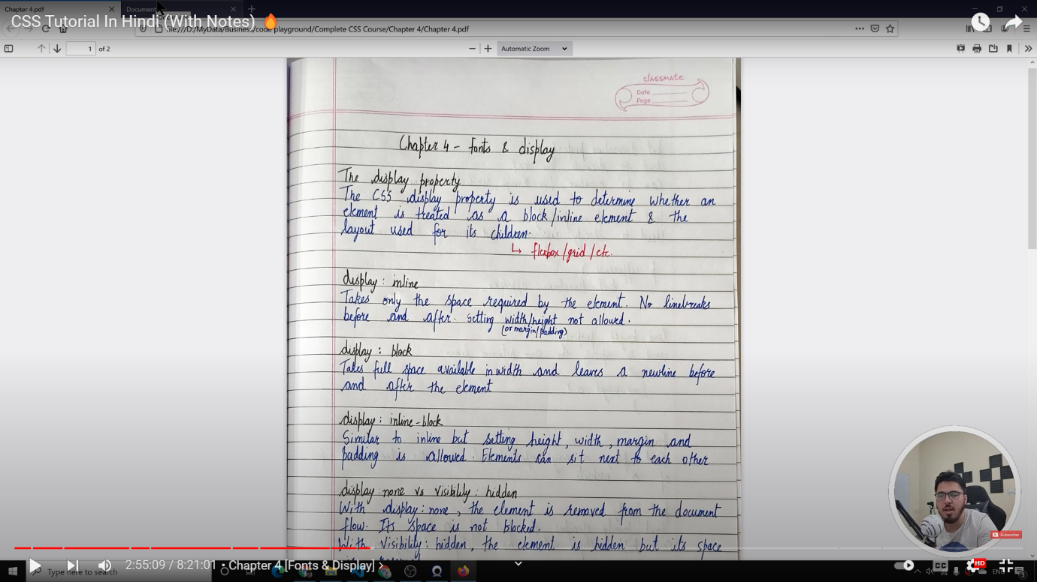

Display : none VS visibility : hidden

Display :none( element doom se completely khatam hojye ga )

Visibility : hidden( element only hidden hoga )

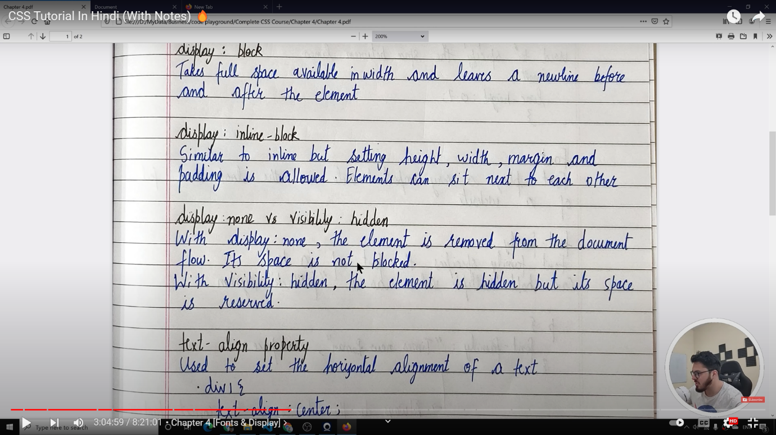

Text -align :

It will align the text to left , right ,centre by

Text-align : left ;

Text-align : centre ;

Text-align : right ;

TEXT-DECORATION :

1. text-decoration: underline; 'd far rather be happy than right any day.

Note : Mdn reference

TEXT-Transform :

NOTE :MDN reference

Q.

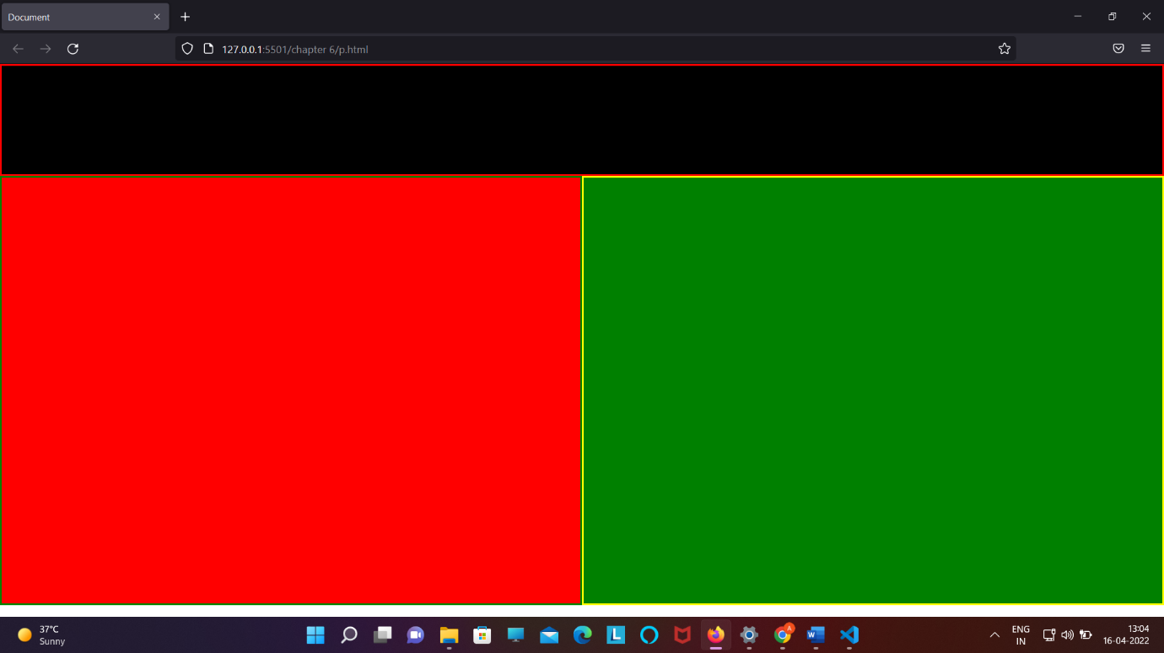

Html code :

<!DOCTYPE html>

<html lang="en">

<head>

  <meta charset="UTF-8">

  <meta http-equiv="X-UA-Compatible" content="IE=edge">

  <meta name="viewport" content="width=device-width, initial-scale=1.0">

  <title>Document</title>

  <link rel="stylesheet" href="pr.css">

</head>

<body>

  <nav class="blacknav"></nav>

  <div class="reddiv"></div><div class="greendiv"></div>

</body>

</html>

Css code : (note be remember of space given in between two div )

*{

*margin*: 0px;

*padding*: 0px;

*box-sizing*: border-box;

}

.blacknav{

  /* width: 1064px; */

*height*: 148px;

*background-color*: black;

*border*: 3px solid red;

}

.reddiv{

*display*: inline-block;

*width*: 50%;

*height*: 568px;

*background-color*: red;

*border*: 3px solid green;

}

.greendiv{

*display*: inline-block;

*width*: 50%;

*height*: 568px;

*background-color*:green;

*border*: 3px solid yellow;

}

Q.REMOVE THE UNDERLINE FROM LINK

Text-decoration : none

CHAPTER – 5:

* OTHER UNITS OTHER THAN PX :

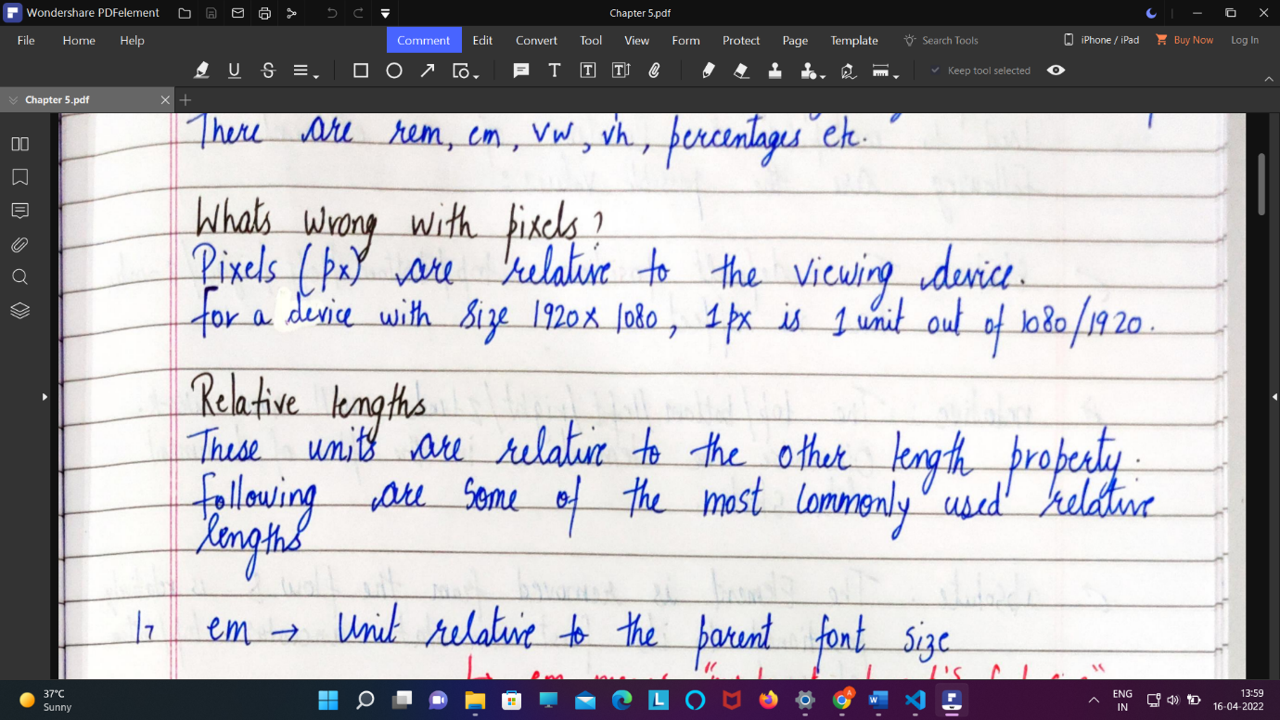

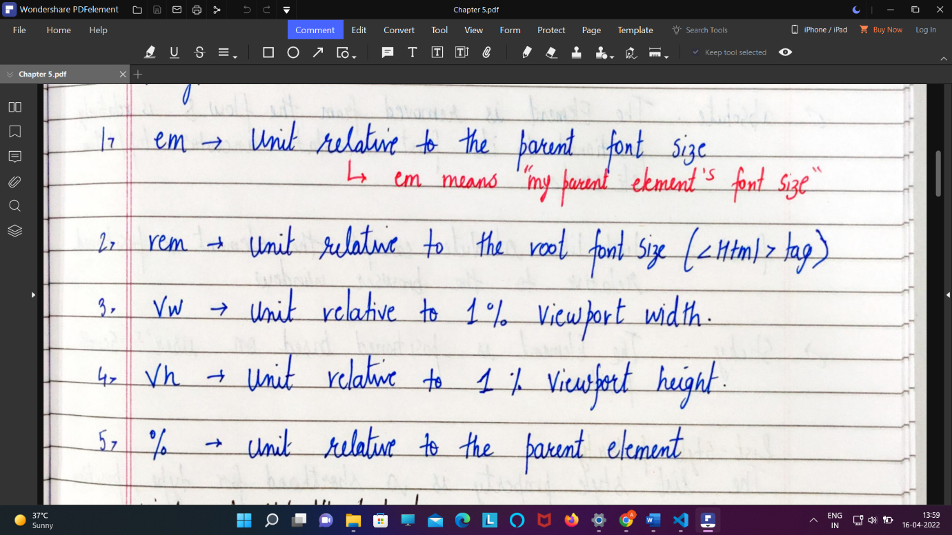

1. Em
2. <!DOCTYPE html>
3. <html lang="en">
4. <head>
5. <meta charset="UTF-8">
6. <meta http-equiv="X-UA-Compatible" content="IE=edge">
7. <meta name="viewport" content="width=device-width, initial-scale=1.0">
8. <title>Document</title>
9. <link rel="stylesheet" href="pr.css">
10. </head>
11. <body >
12. <header class="classheader">
13. <h1>This about font size</h1>
14. <article class="classarticle">
15. Lorem ipsum dolor sit amet, consectetur adipisicing elit. Dolorem molestiae voluptates ex porro vel architecto doloribus optio, mollitia ipsa? Maxime eos cupiditate nihil velit rem recusandae eaque ratione iure assumenda!
16. </article>
17. </header>
18. </body>
20. </html>

Css code :

*{

*margin*: 0px;

*padding*: 0px;

*box-sizing*: border-box;

}

.classheader{

*font-size*: 40px;

}

.classarticle{

*font-size*: 2em;

}

Max height/width or min height/ width :

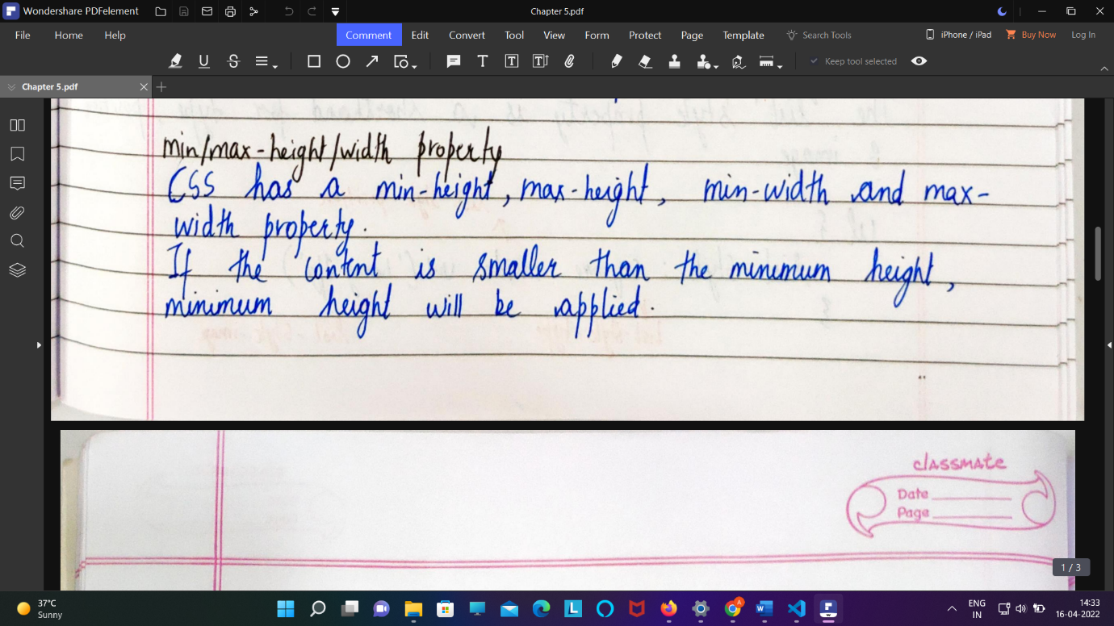

* POSTION :

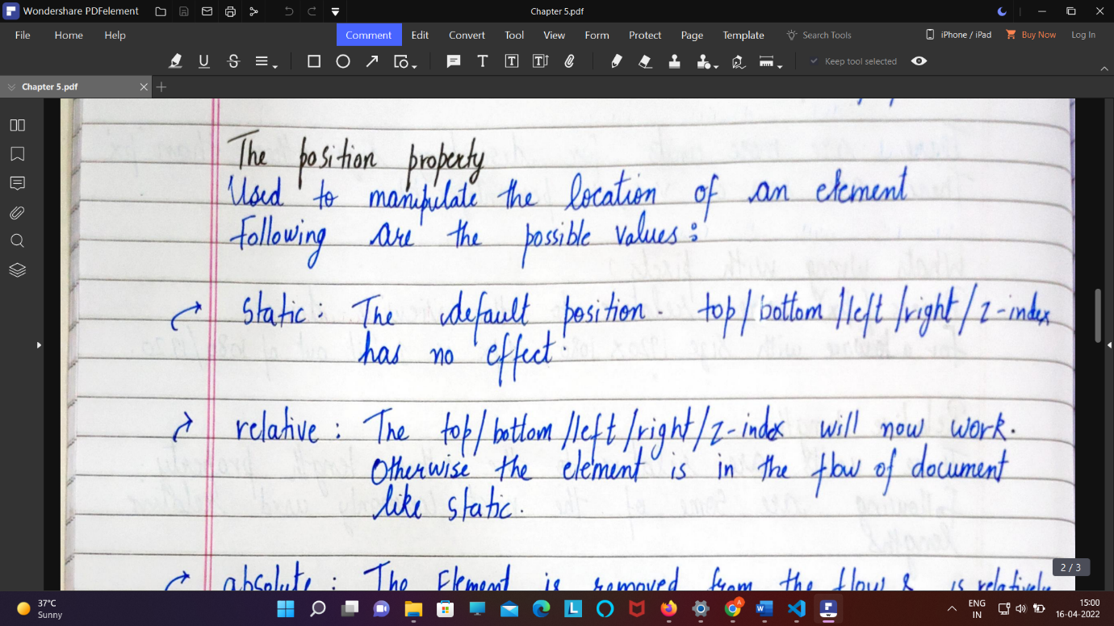

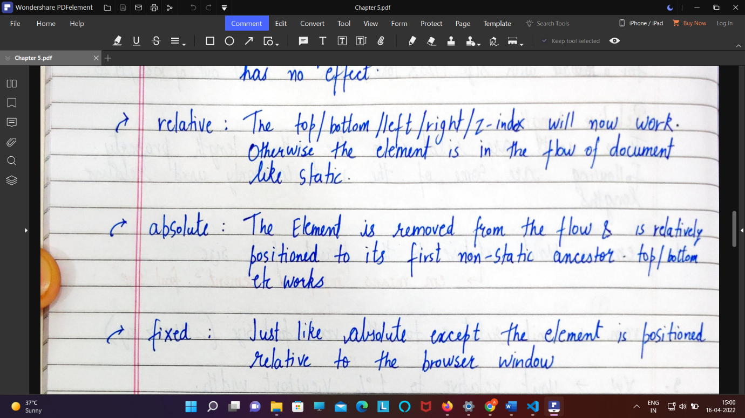

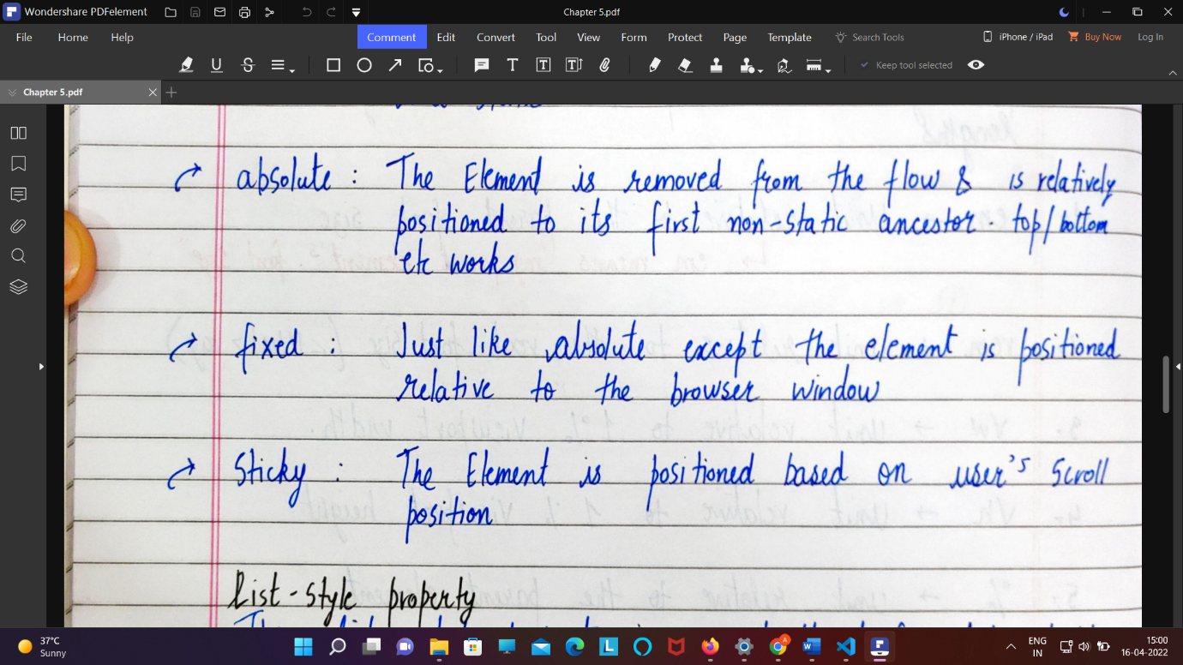

Difference between fixed and sticky :

The **position: fixed** means fixed to the viewport. We provide the position values (top, bottom, right, or left) and the element stays there when the user is scrolling. No matter what is happening on screen the fixed element will not move at all.

The **position: sticky** means the element will scroll until it reaches the offset value given to it by the user and then stays in its position. Sticky element always stays within its parent block and as soon as the parent block leaves the screen as an effect of scrolling, sticky elements also leave with it.

Q .

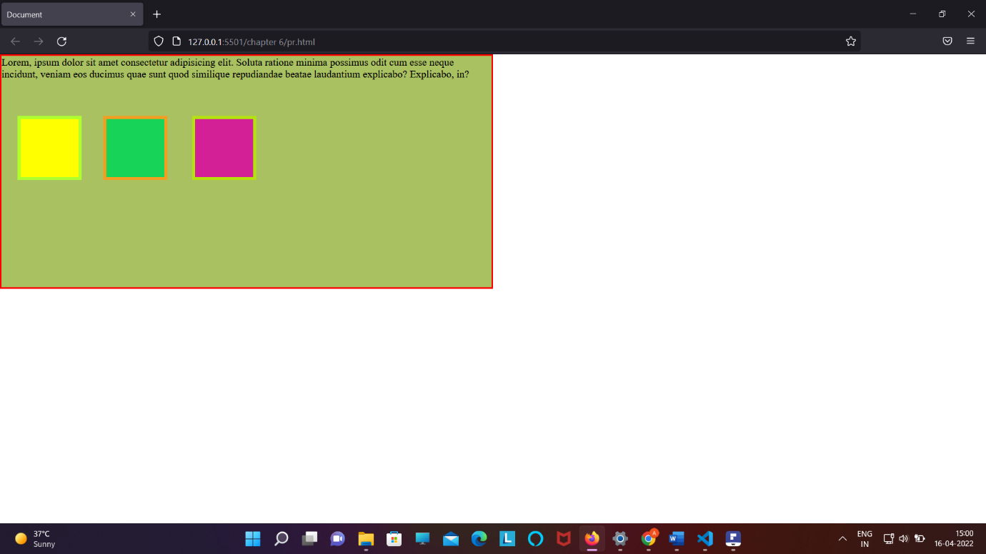

Html code :

<!DOCTYPE html>

<html lang="en">

<head>

    <meta charset="UTF-8">

    <meta http-equiv="X-UA-Compatible" content="IE=edge">

    <meta name="viewport" content="width=device-width, initial-scale=1.0">

    <title>Document</title>

    <link rel="stylesheet" href="pr.css">

</head>

<body>

    <div class="box1">

        Lorem, ipsum dolor sit amet consectetur adipisicing elit. Soluta ratione minima possimus odit cum esse neque incidunt, veniam eos ducimus quae sunt quod similique repudiandae beatae laudantium explicabo? Explicabo, in?

        <div class="subbox1"></div>

        <div class="subbox2"></div>

        <div class="subbox3"></div>

    </div>

</body>

</html>

Css code :

*{

*padding*: 0;

*margin*: 0;

*box-sizing*: border-box;

}

.box1{

*width*: 50vw;

*height*: 50vh;

*background-color*: rgb(170, 193, 97);

*border*: 3px red solid;

}

.subbox1{

*display*: inline-block;

*width*: 100px;

*height*: 100px;

*background-color*: yellow;

*position*: absolute;

*border*: 5px greenyellow solid;

*top*: 96px;

*left*: 27px;

}

.subbox2{

*display*: inline-block;

*width*: 100px;

*height*: 100px;

*background-color*: rgb(23, 212, 89);

*position*: absolute;

*border*: 5px rgb(241, 159, 35) solid;

*top*: 96px;

*left*: 161px;

}

.subbox3{

*display*: inline-block;

*width*: 100px;

*height*: 100px;

*background-color*: rgb(211, 32, 151);

*position*: absolute;

*border*: 5px rgb(180, 226, 14) solid;

*top*: 96px;

*left*: 299px;

}

Q. creating a sticky nav bar (hint postion :sticky ;

Top 0; )

.classnav{

*height*: 25vh;

*background-color*: black;

*position*: sticky;

*top*: 0;

}

Z index property : ( z-index : )

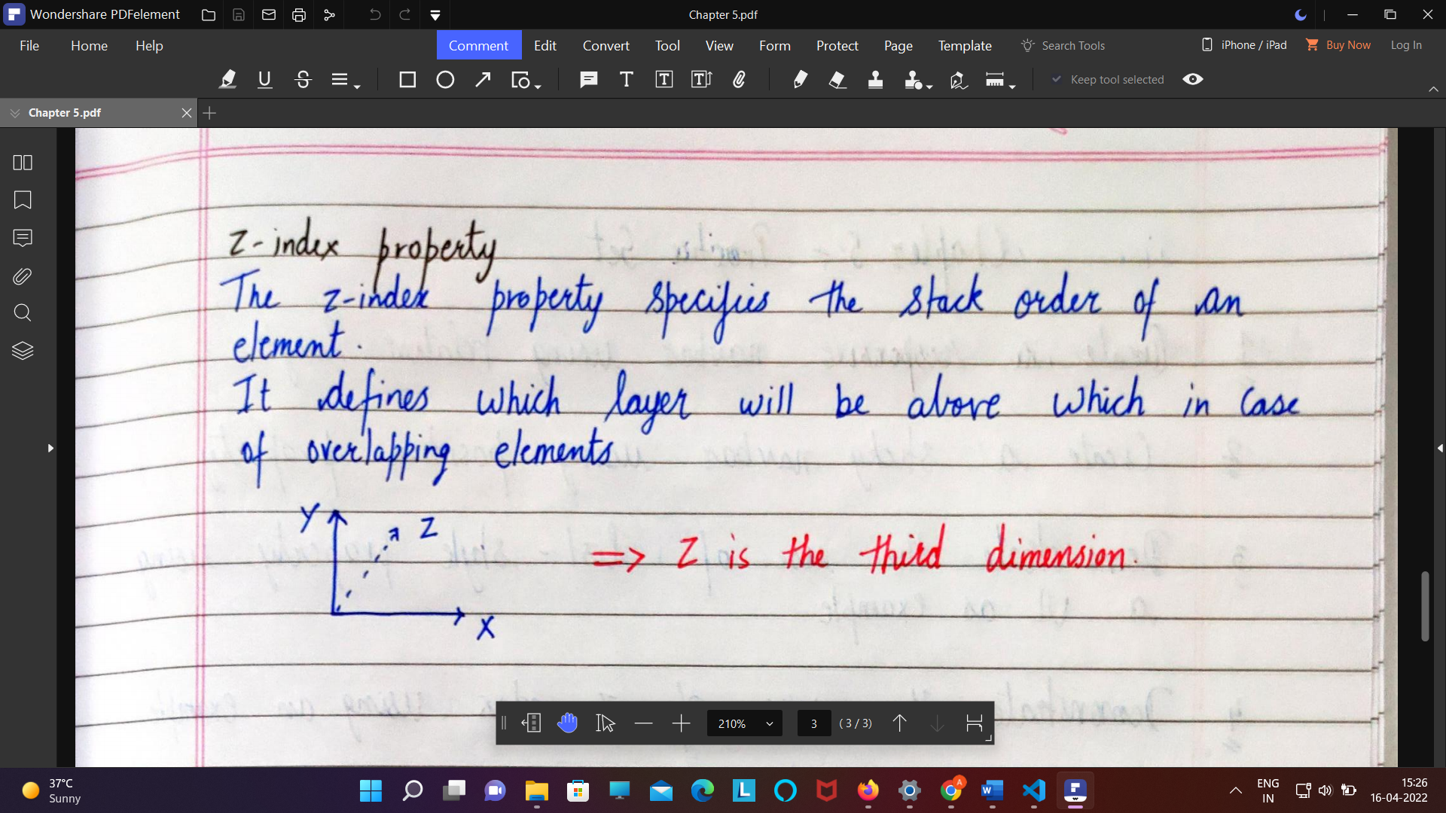

Note : jiska z index jada rhega wo upar rahega

List -style :

ul {  
  list-style: square inside url("sqpurple.gif");  
}

List style shortend :

The list-style property is a shorthand for the following properties:

* [list-style-type](https://www.w3schools.com/cssref/pr_list-style-type.asp)
* [list-style-position](https://www.w3schools.com/cssref/pr_list-style-position.asp)
* [list-style-image](https://www.w3schools.com/cssref/pr_list-style-image.asp)

chapter 5

13 . Float :

13.1 clear : left/right/center/both

## **Definition and Usage**

The clear property controls the flow next to floated elements.

The clear property specifies what should happen with the element that is next to a floating element.

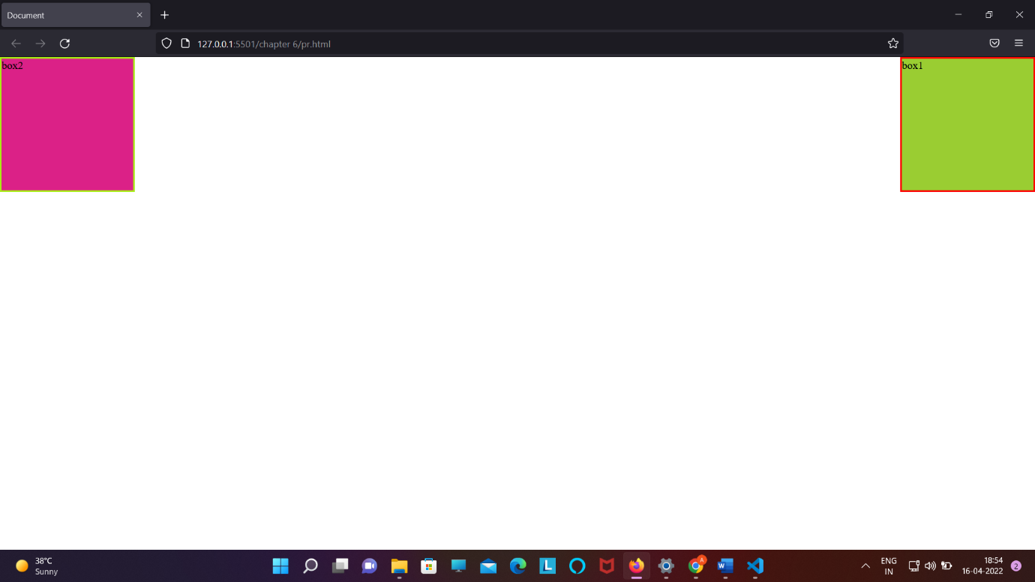

Code :

<!DOCTYPE html>

<html lang="en">

<head>

    <meta charset="UTF-8">

    <meta http-equiv="X-UA-Compatible" content="IE=edge">

    <meta name="viewport" content="width=device-width, initial-scale=1.0">

    <title>Document</title>

    <link rel="stylesheet" href="pr.css">

    <style>

        .box1 {

*width*: 200px;

*height*: 200px;

*background-color*: yellowgreen;

*border*: 3px solid red;

*float*: right;

        }

        .box2 {

*width*: 200px;

*height*: 200px;

*background-color*: rgb(219, 33, 135);

*border*: 3px solid rgb(168, 236, 21);

*float*: left;

        }

    </style>

</head>

<body>

    <div class="box1">box1</div>

    <div class="box2">box2</div>

</body>

</html>

14. FLEXBOX :

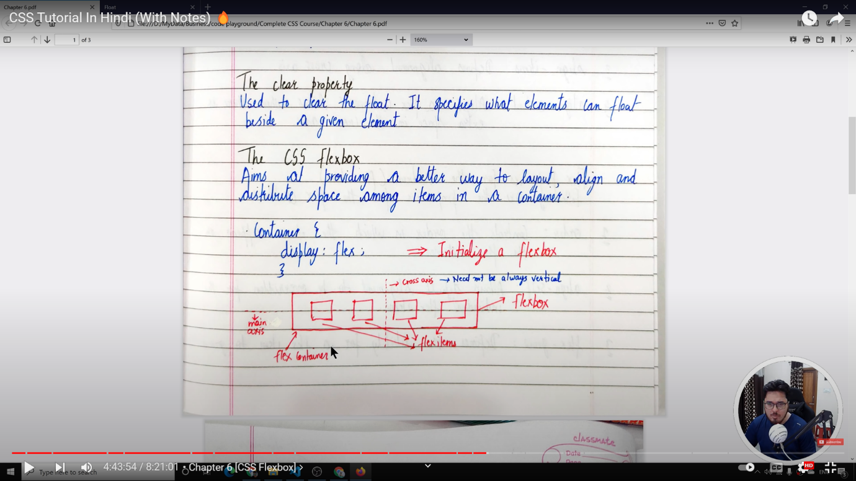

Flex is both container and item property ;

Flex container property :

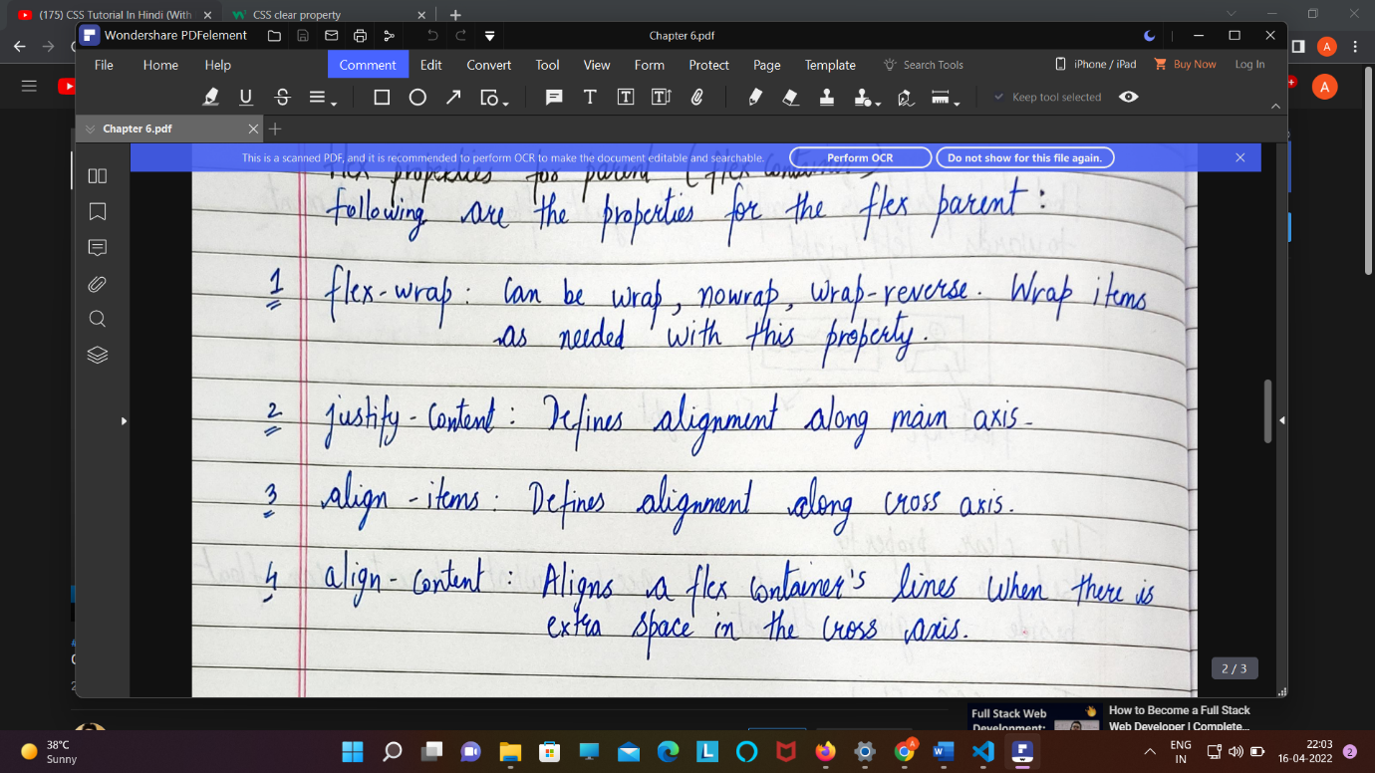

1. Display : flex ;
2. Flex-direction : row / column /row-reverse /column-reverse

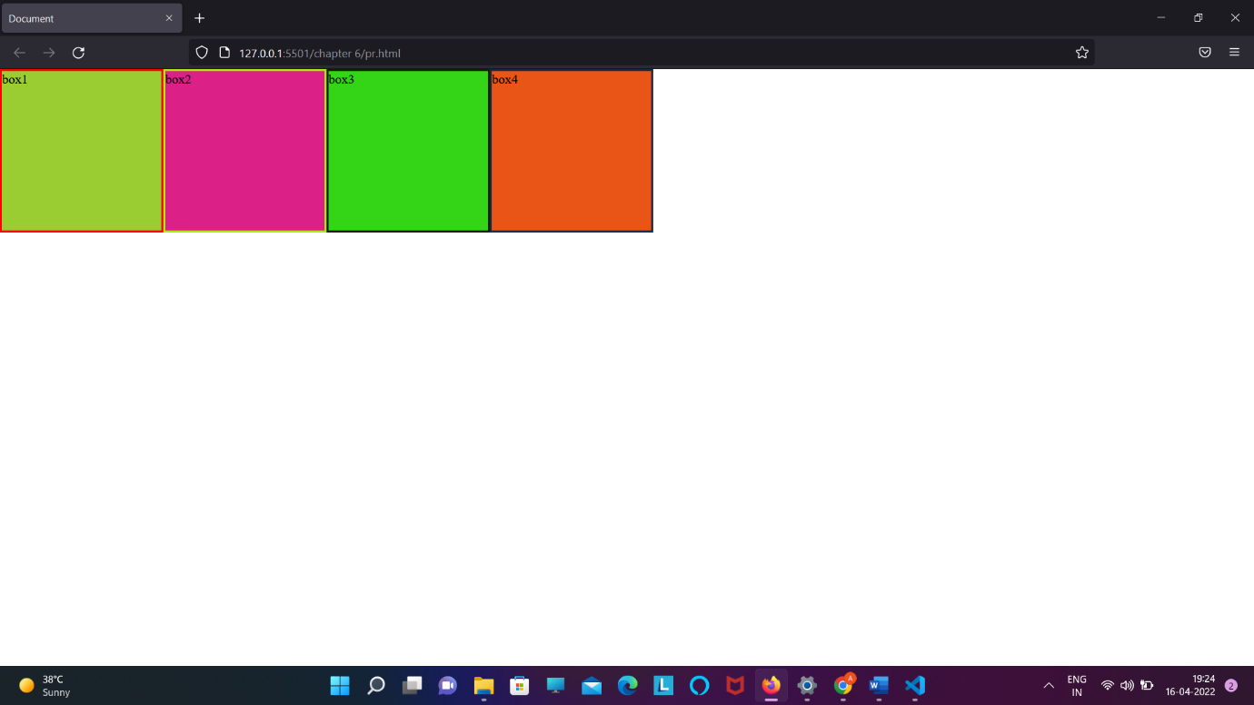

1. Wrap :

Flex-wrap : wrap / wrap-reverse / nowrap

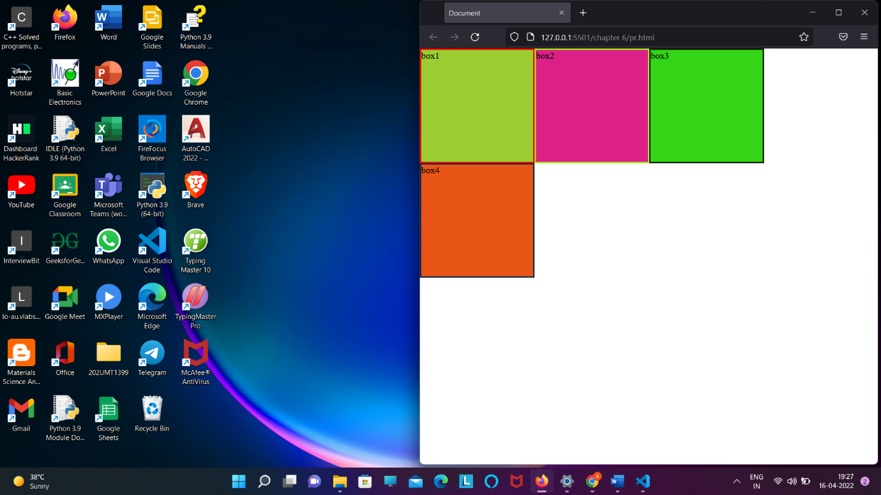

4 . justify-content :

It used to keep the content of container at centre from x-axis wise

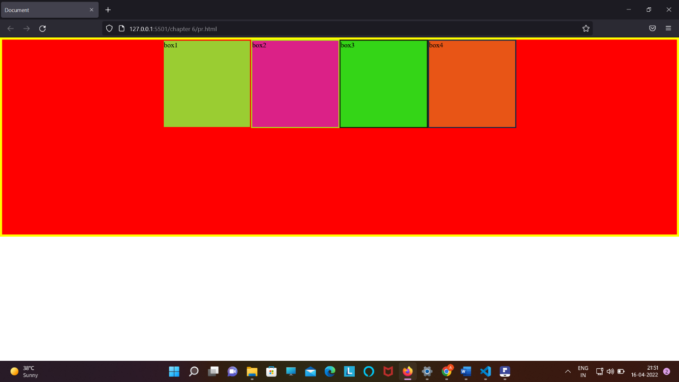

5 . align-item : centre ; /* use to keep item of container to centre in y-axis

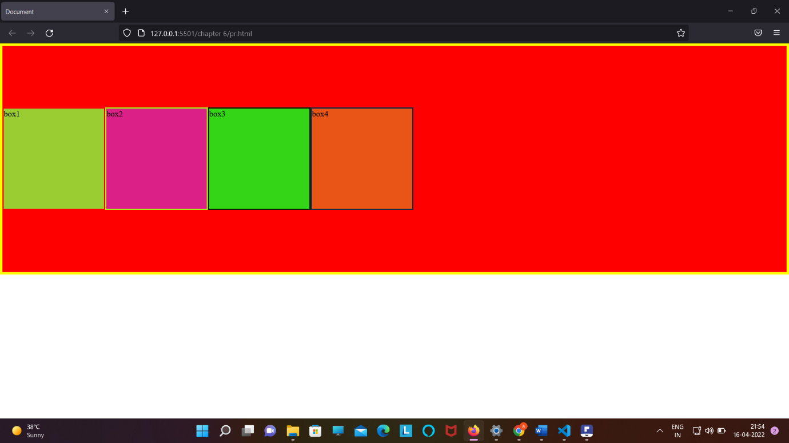

6 . align-content : to remove the space when we are minimize the website

Before align-content :

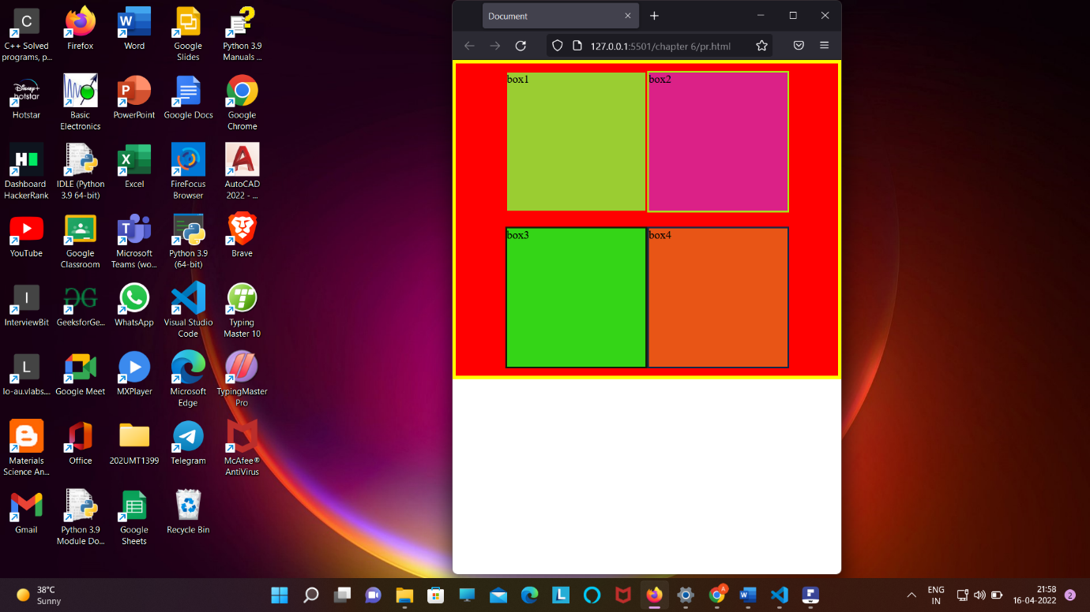

There is a gap between two

* After align-content :center ;

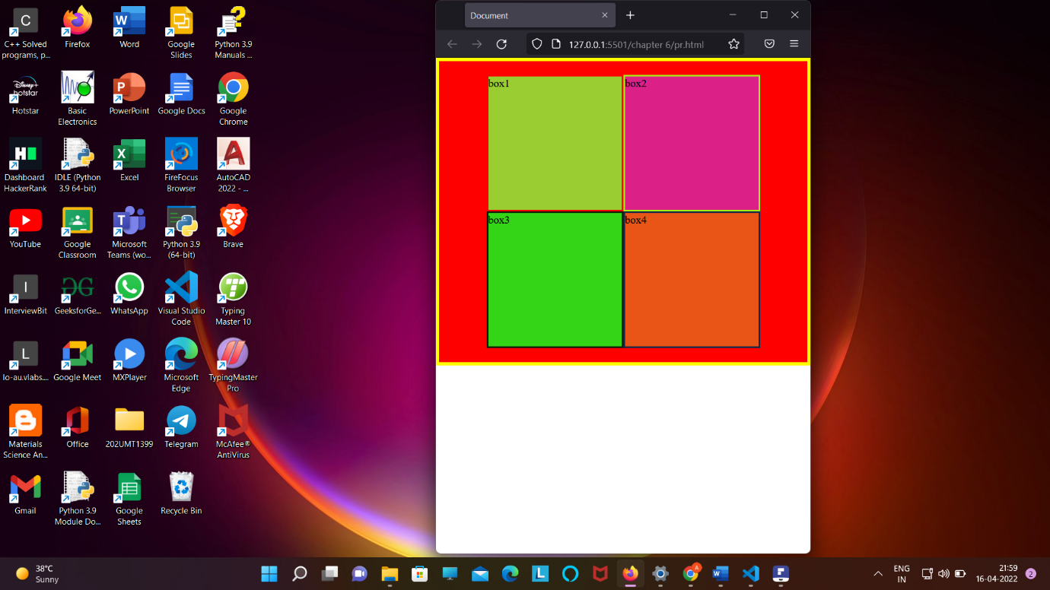

Note : the space have been removed

* PROPERTY FOR FLEX ITEM :

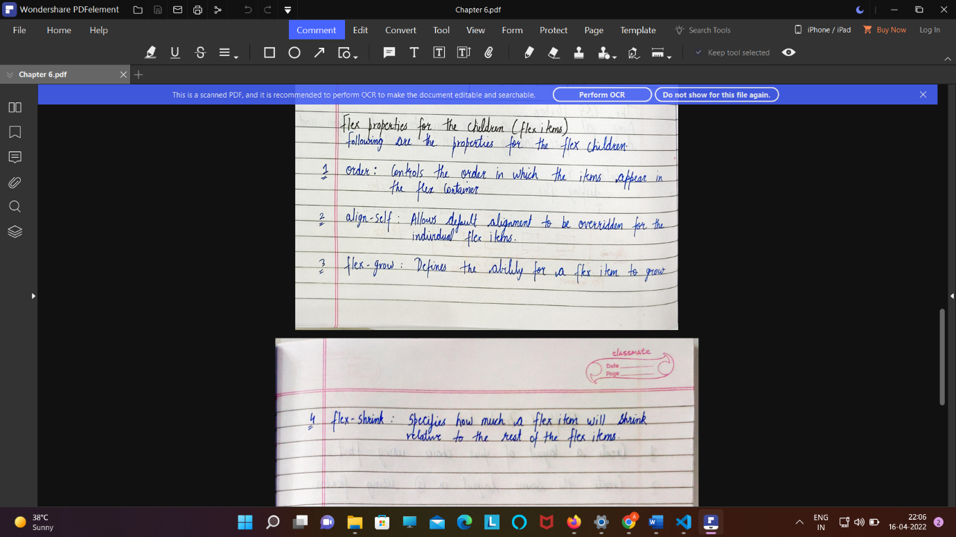

*flex-grow*: 5;

GRID : used to make layout inside a container

Grid can be container type or item type

Grid container type :

1 . display :grid;

2 .grid-coloumn-gap : x px;

3 . grid-row-gap : x px;

Shortened :

Grid-gap: row-gap, column-gap ;

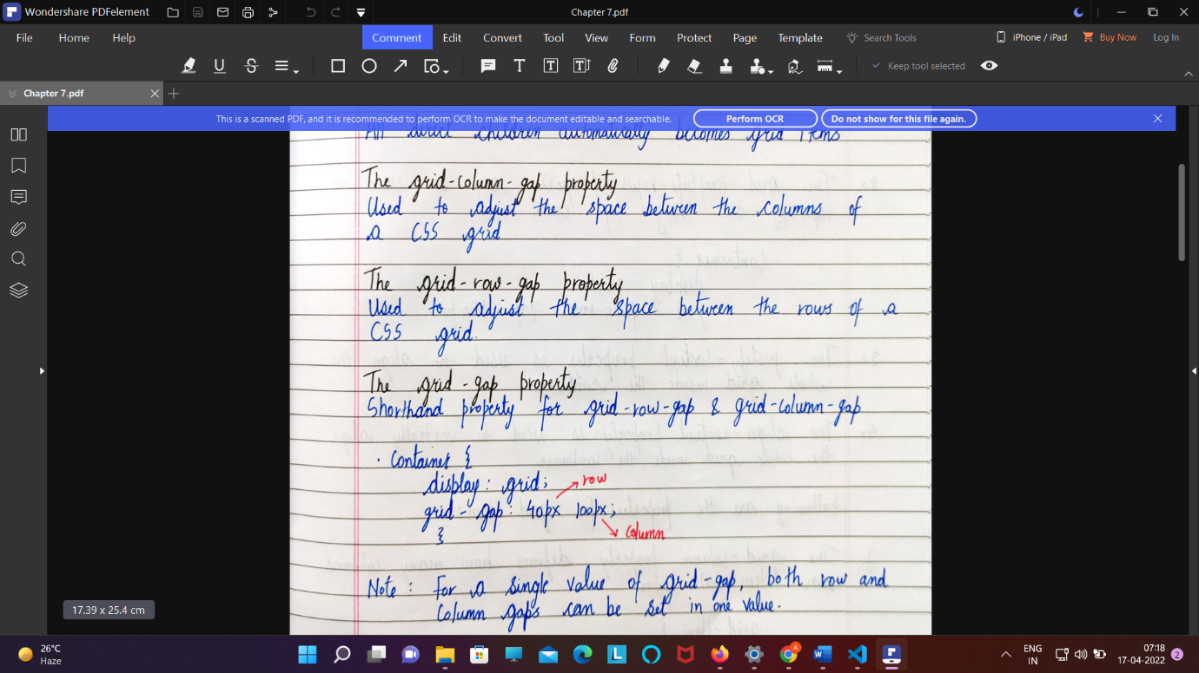

4 . grid-template-column : auto auto ;

/* make two coloumn */

Gird-template shortened :

*grid-template*: repeat(7, 15vh) / repeat(3, 1fr);

first : row second wala coloumn fr=fraction

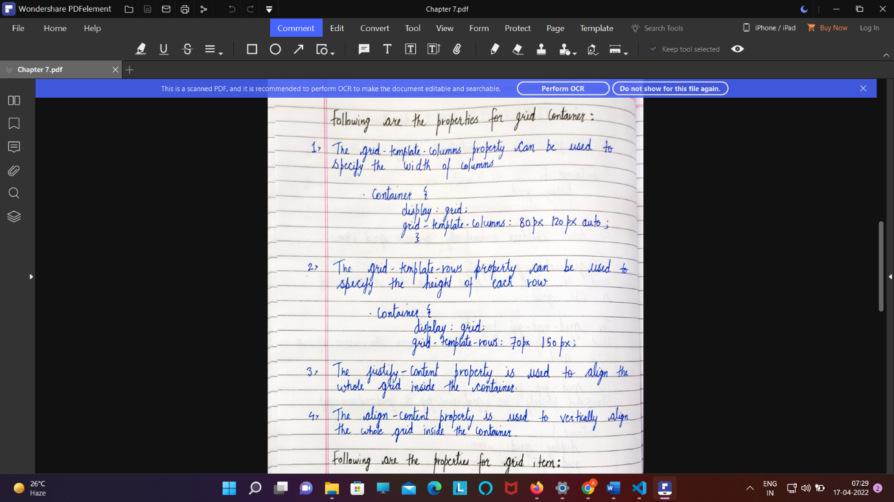

5. grid-template-area :

*grid-template-areas*:

    "card1 card1 card1"

    "card1 card1 card1"

    "card2 card3 card3"

    "card4 card4 card5"

    "card6 card7 card5"

    "card8 card8 card9";

}

Grid item property :

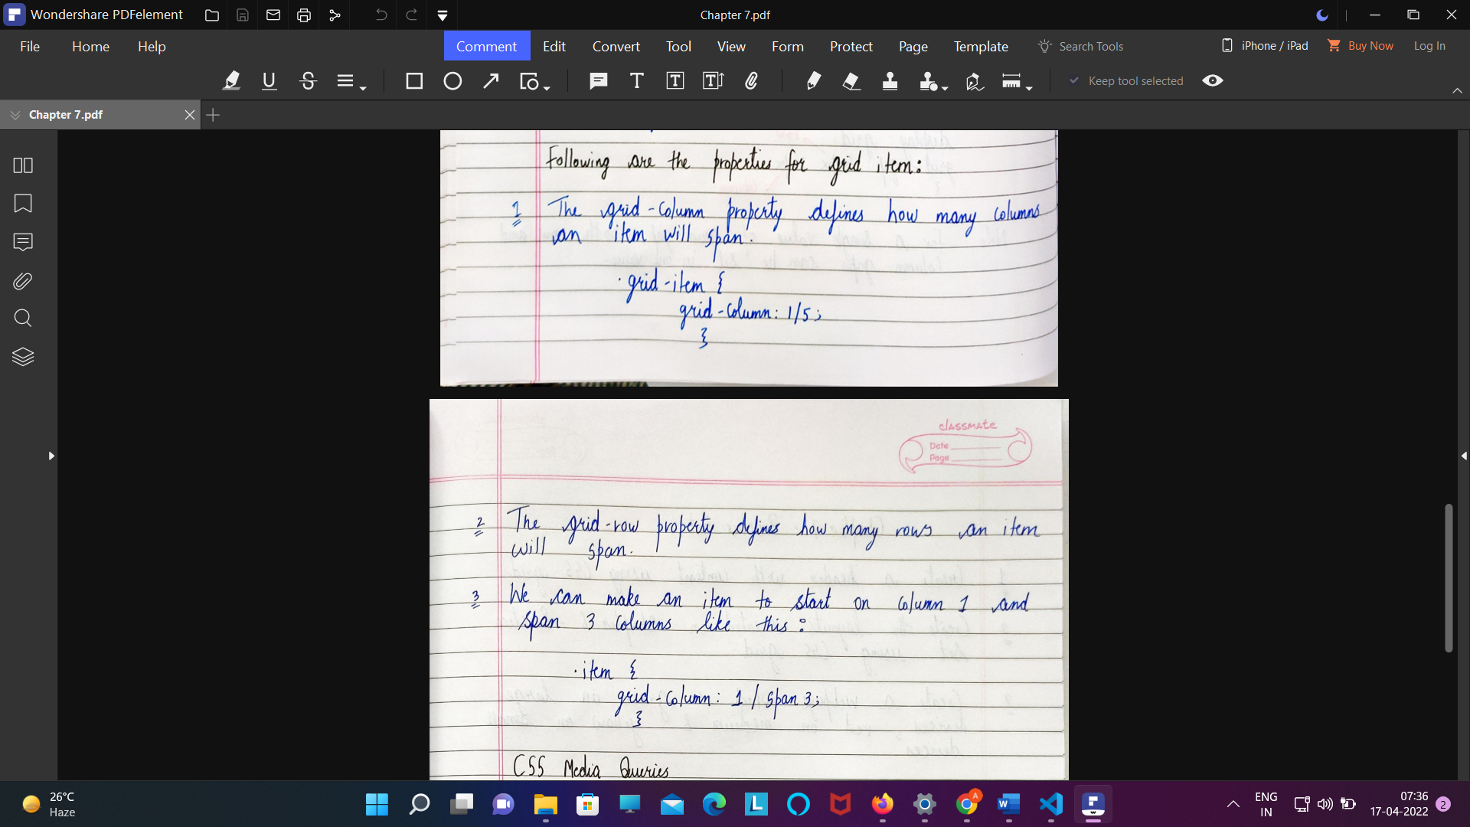

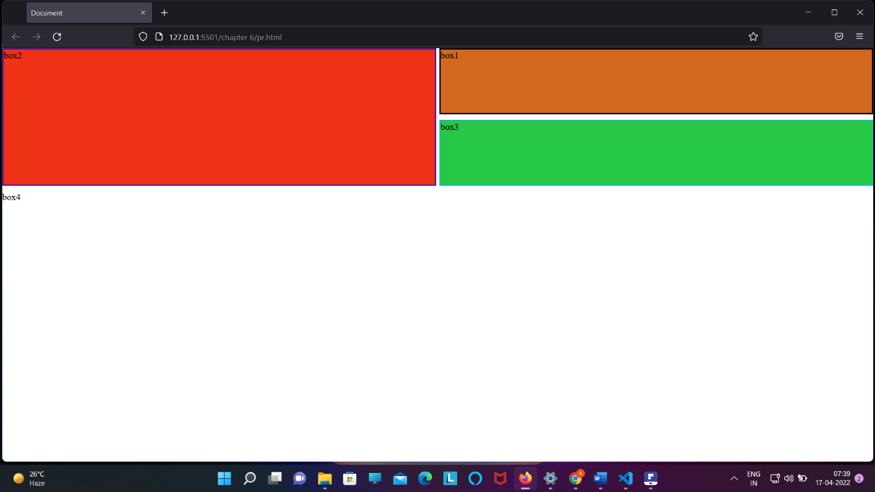

3 . grid-area;

16. CSS MEDIA QUIRY :

Syntax :

@media screen and ( max-width: 800px){

Body{

Background-color:yellow;

}

}

*************Chapter -8**************

17 . TRANSFORM : refer w3 school website :

Link : https://www.w3schools.com/css/css3_2dtransforms.asp

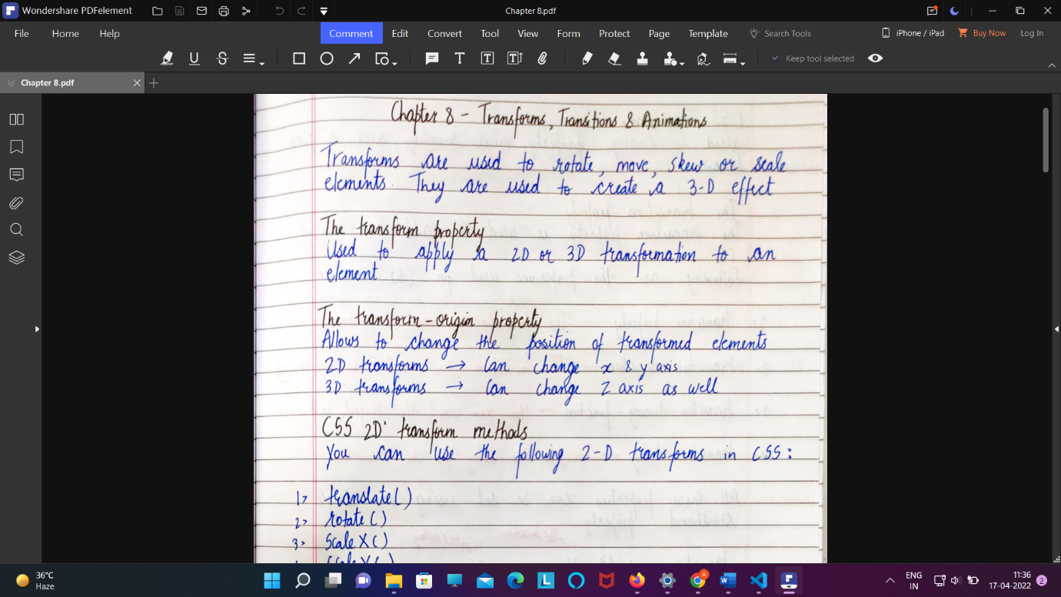

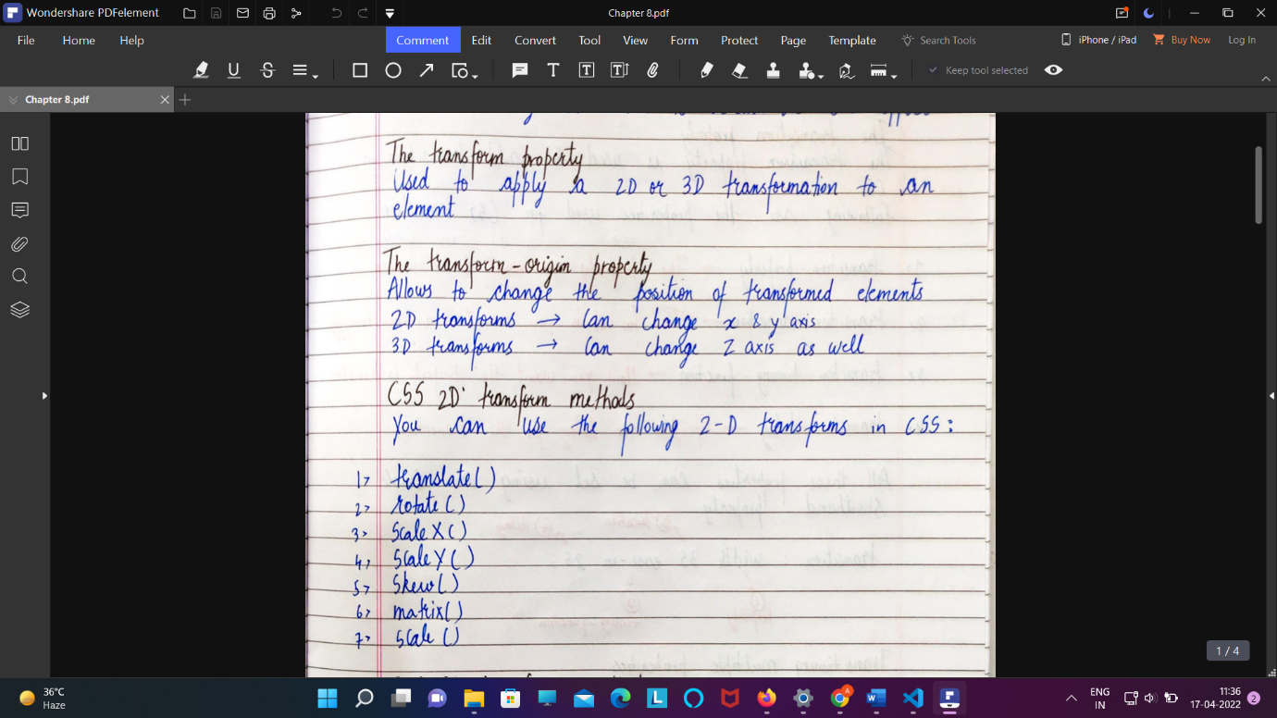

* 3 d transformation :

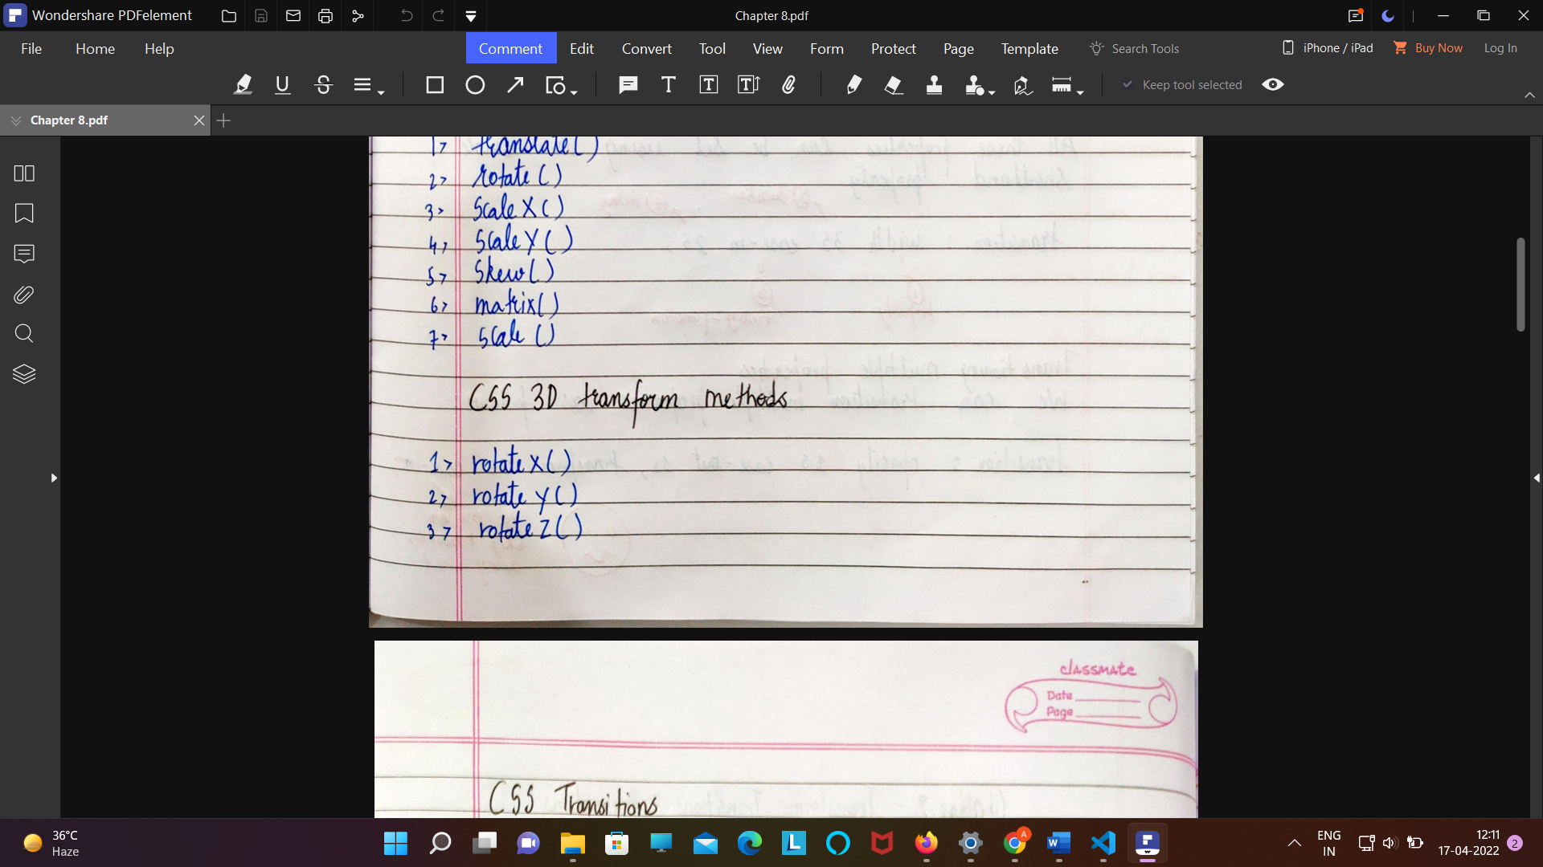

Rotate-shortened :

1.Transform:rotate(x-axis,y-axis,z-axis)

We have also : transform:rotateX() or rotateY() or rotateZ()

18 .Transition :

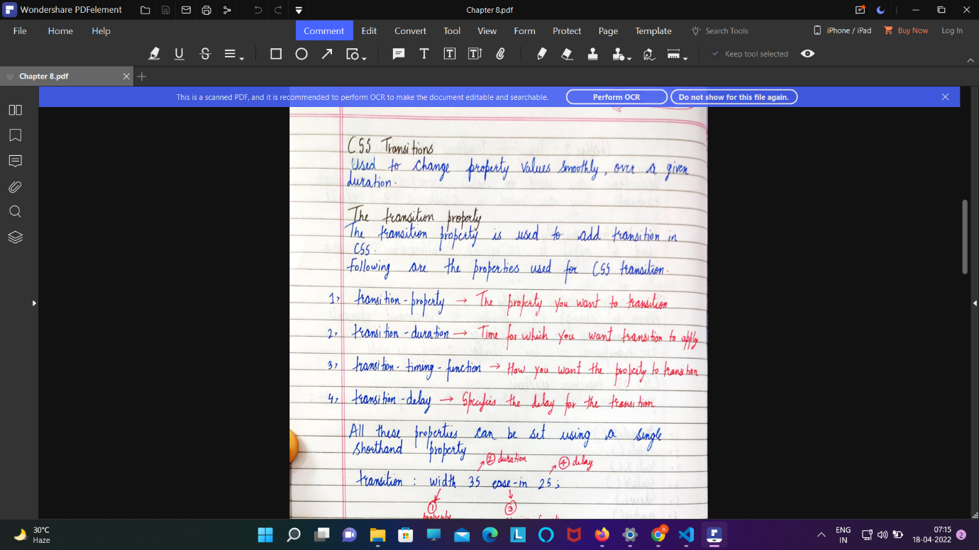

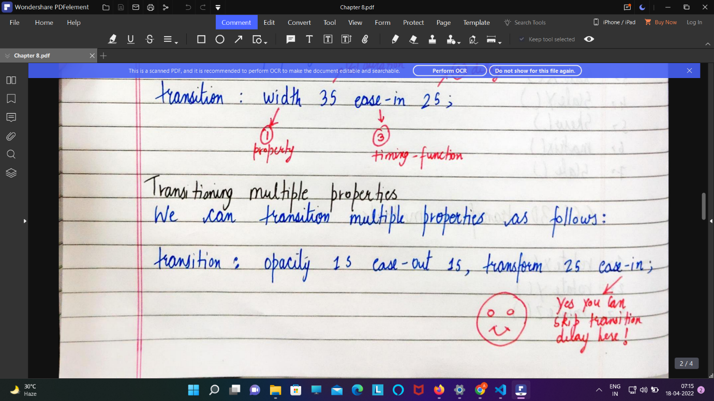

Transition link : <https://www.w3schools.com/css/css3_transitions.asp>

19 . ANIMATION :

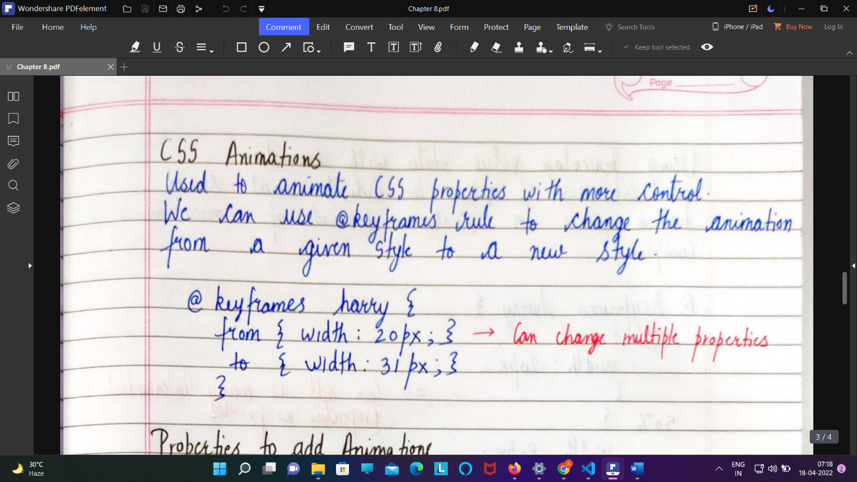

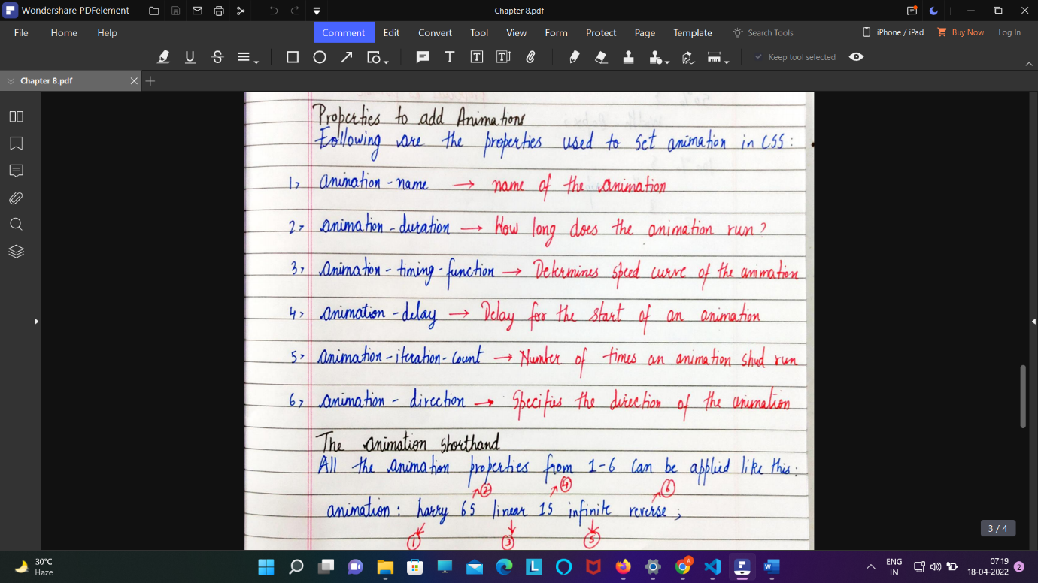

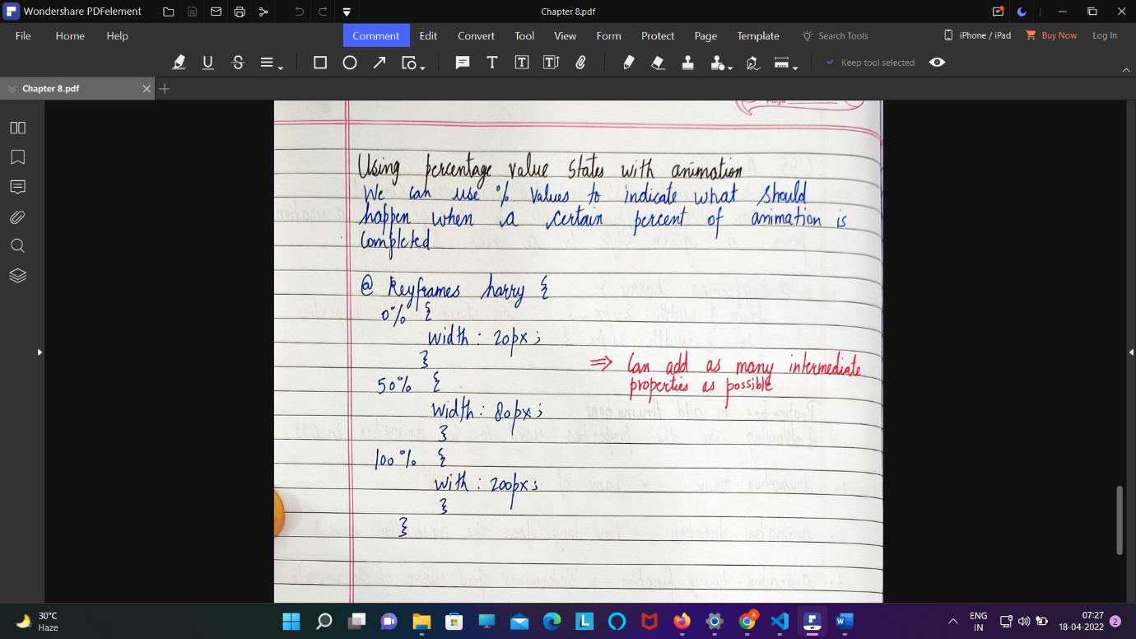

1Animation link : <https://www.w3schools.com/css/css3_animations.asp>

Links and Button 🡪

Way of writing button –

1. Button syntax (<button>click here</here>)
2. Background color
3. Border : none;
4. Curser: pointer (for bringing curser)

To remove underline from link 🡪

a{

Text-decoration :none ;

}

a {

            text-decoration: none;

            color: black;

        }

Pseudo selector for link ->

1. **Hover**is used to change the color of text or background of a button as soon as you hover that part. The code for this is as below

a : hover{

background -color: yellow;

}

a:hover{

            background-color: rgb(29, 29, 26);

        }

1. The next Pseudo selector is **Visited.** As soon as you visit the anchor tag button and click the link mentioned, it changes its color. To apply this property, write the code as follows-

a :visted{

color :red;

note : try to use color only not back ground color

}

a:visited{

            color: yellow;

        }

1. The next selector is **Active.** If you visit any button, and click it, it becomes active and showcases with different properties. The code for this is-
2. a:active{
3. background-color:darkblue;
4. }

Applying same property in button :

note : try to use color only not back ground color

.btn:hover{

            color: red;

            background-color: rgb(180, 235, 180);

        }

Where .btn is class=”btn” of button define by me

Total code 🡪

"UTF-8">

    <meta name="viewport" content="width=device-width, initial-scale=1.0">

    <meta http-equiv="X-UA-Compatible" content="ie=edge">

    <title>Pseudo selectors & more designing</title>

    <style>

        .container{

            border: 2px solid red;

            background-color: rgb(223, 245, 201);

            padding: 34px;

            margin: 34px auto;

            width: 666px;

        }

        a{

            text-decoration: none;

            color: black;

        }

        a:hover{

            color: rgb(5, 0, 0);

            background-color: rgb(221, 166, 38);

        }

        a:visited{

            background-color: yellow;

        }

        a:active{

            background-color:darkblue;

        }

        .btn{

            font-family: 'Segoe UI', Tahoma, Geneva, Verdana, sans-serif;

            font-weight: bold;

            background-color: crimson;

            padding:6px;

            border: none;

            cursor:pointer;

            font-size: 13px;

            border-radius: 4px;

        }

        .btn:hover{

            color:darkgoldenrod;

            background-color:rgb(223, 245, 201);

            border: 2px solid black;

        }

    </style>

</head>

<body>

    <div class="container" id="cont1">

        <h3>This is my heading</h3>

        <p>Lorem ipsum dolor sit amet consectetur adipisicing elit. Obcaecati, reprehenderit. Quam culpa eius aliquam id cumque saepe, provident odio sed eos quia nihil modi error voluptate vero autem quibusdam aperiam exercitationem! Quam, consequuntur velit.</p>

        <a href="https://yahoo.com" class="btn">Read more</a>

        <button class="btn">Contact us</button>

    </div>

</body>

</html>

4-- [:link](https://www.w3schools.com/cssref/sel_link.asp) Selects all unvisited links

TEXT 🡪

1. Color :
2. Text-align : by default align is left
3. Text-align :left;
4. Text-align :right;
5. Text-align :center;
6. Text-align :justify;

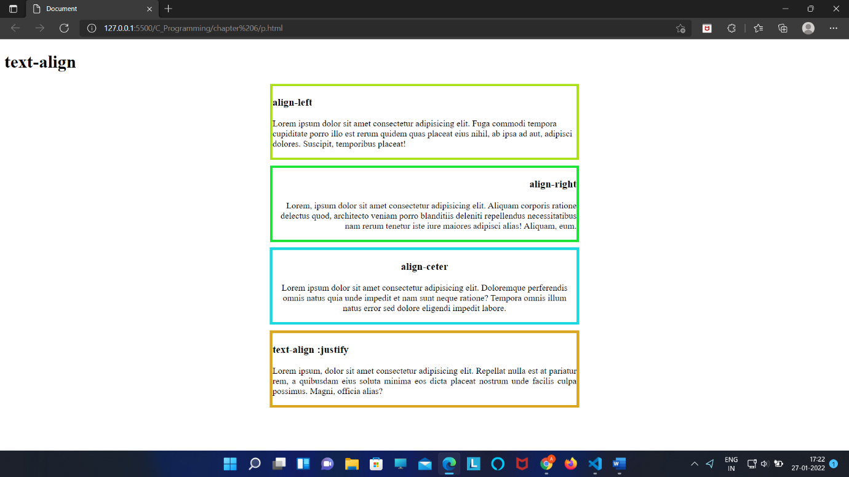

<!DOCTYPE html>

<html lang="en">

<head>

    <meta charset="UTF-8">

    <meta http-equiv="X-UA-Compatible" content="IE=edge">

    <meta name="viewport" content="width=device-width, initial-scale=1.0">

    <title>Document</title>

    <link rel="stylesheet" href="pr.css">

</head>

<body>

    <header>

        <h1>text-align</h1>

        <div id="div1">

            <h3>align-left</h3>

            <p>Lorem ipsum dolor sit amet consectetur adipisicing elit. Fuga commodi tempora cupiditate porro illo est rerum quidem quas placeat eius nihil, ab ipsa ad aut, adipisci dolores. Suscipit, temporibus placeat!</p>

        </div>

        <div id="div2">

        <h3>align-right</h3>

        <p>Lorem, ipsum dolor sit amet consectetur adipisicing elit. Aliquam corporis ratione delectus quod, architecto veniam porro blanditiis deleniti repellendus necessitatibus nam rerum tenetur iste iure maiores adipisci alias! Aliquam, eum.</p>

        </div>

        <div id="div3">

            <h3>align-ceter</h3>

            <p>Lorem ipsum dolor sit amet consectetur adipisicing elit. Doloremque perferendis omnis natus quia unde impedit et nam sunt neque ratione? Tempora omnis illum natus error sed dolore eligendi impedit labore.</p>

        </div>

        <div id="div4">

            <h3>text-align :justify</h3>

            <p>Lorem ipsum, dolor sit amet consectetur adipisicing elit. Repellat nulla est at pariatur rem, a quibusdam eius soluta minima eos dicta placeat nostrum unde facilis culpa possimus. Magni, officia alias?</p>

        </div>

    </header>

</body>

</html>

#div1{

    width: 550px;

    border: 4px solid rgb(169, 223, 21);

    text-align: left;

    margin: auto;

}

#div2{

    border: 4px solid rgb(24, 226, 51);

    text-align: right;

    width: 550px;

    margin: auto;

    margin-top: 10px;

}

#div3{

    border: 5px solid rgb(26, 216, 223);

    width: 550px;

    text-align: center;

    margin: auto;

    margin-top: 10px;

}

#div4{

    border: 5px solid goldenrod;

    text-align :justify;

    margin: auto;

    margin-top: 10px;

    width: 550px;

}

1. Writing something in like in urdu

Direction :rtl; /* right to left*/ by default it will left to right